Erasmus+ KA 210

Strategic Partnership Programme in Vocational Education and Training

Programme Title:

“Innovative Methods in Teaching And Learning Welding in Vocational Education And Training”

Program Acronym: " InnoWeld "

Program Code:
"2023-2-TR01-KA210-VET-000182985"

InnoWeld MANUAL

photo

"The project is funded by the Erasmus+ Programme of the European Union. The support of the European Commission and the Organizing Body of Turkey for the production of this material does not constitute an endorsement of the contents which reflects the views only of the authors and the Commission cannot be held responsible for any use which may be made of the information contained herein."

“This project is Funded by the Erasmus+ Program of the European Union. However, European Commission and Turkish National Agency cannot be held responsible for any use which may be made of the information contained therein”


COORDINATOR:
Şehit Mehmet Coşkun Kılıç Vocational Technical Anatolian High School - (Τurkey)

PARTICIPANTS:
2 EC Piraeus (Greece)
Einstein De Lorenzo Institute of Higher Education Potenza (Ιtaly)
Vác Vocational Training Center Király Endre Technical and Vocational School (Hungary)



Summary

The subject of the program is Welding as a fabrication process: More specifically metal cutting in various shapes and then joining them together using different methods of welding.
In this context, the issues and needs addressed are:
• the lack of a practical curriculum in welding education/training and the antiquated nature of existing curricula,
• the inadequacy of video tutorials in welding training,
• the problems faced by both pupils and teachers during Welding applications in classrooms
• the importance of working with institutions and partners across Europe
• the demand for qualified personnel in the relevant construction, metals sectors,
steel machinery and structures.
Based on the above, the objectives of this cooperation are:
• During the 18-month project, teachers from four different countries and four different schools specialising in machinery, metal and metal professions construction, which teach welding courses, will enhance professional their knowledge and skills in welding practices in vocational education.
• Improving the skills and knowledge of vocational education teachers on different types of equipment and applications used in welding training;
• Enhance teachers' knowledge of welding practices. They are used in industry and construction.
• Improvement of the quality of welding training provided to partners Schools.
• Transfer of good welding practices between partners.
• Improving the quality of welding teaching and learning.
• Increase intercultural awareness among teachers and pupils in the schools participating in the project.
• Strengthening European values (human rights, democracy, respect different cultures) through the programme.

TIG WELDING
Πίνακας περιεχομένων

1. SAFETY RULES & PERSONAL PROTECTIVE EQUIPMENT 7
1.1 General safety rules 7
1.2 Personal protection measures 8
2. INTRODUCTION TO TIG WELDING 10
2.1 Description of the TIG welding method 10
2.2 Where to use 11
2.3 Advantages & Cons 11
3. NECESSARY EQUIPMENT 13
3.1 The basic parts of a TIG assembly 13
3.1.1 TIG welding machine 14
3.1.2 Gas cylinders 15
3.1.3 Torch - welding torch 16
4. TUNGSTEN ELECTRODES 18
4.1 Standardization of tungsten electrodes 18
4.2 Preparing electrodes for use 19
4.3 Electrode grinding 20
4.3.1 General instructions 20
4.3.2 Grinding apparatus and tools 20
5. TIG WELDING RODS 22
5.1 Standardization of TIG welding rods 22
6. PREPARATION BEFORE USE 24
6.1 Welding configuration 24
6.2 Important instructions before use 26
LABORATORY EXERCISES 29
EXERCISE NO. 1 29
‘Disassembly & Assembly of the welding torch (Electrode torches)’ 29
EXERCISE NO. 2 31
‘TIG operation configuration’ 31
EXERCISE NO. 3 34
‘Inert gas flow adjustment of a TIG power station depending on the thickness of the material and the diameter of the ceramic orifice’ 34
EXERCISE NO. 4 36
‘Formation of melting points by TIG welding, without and with the addition of adhesive’ 36
EXERCISE NO. 5 38
‘Melting line formation by TIG welding, without addition of adhesive’ 38
EXERCISE NO. 6 40
‘Melting line formation by TIG welding, with the addition of adhesive’ 40
EXERCISE NO. 7 42
‘Welding TIG head-on, horizontally with the addition of adhesive material’ 42
EXERCISE NO. 8 44
‘External angle TIG welding without the addition of adhesive’ 44
EXERCISE NO. 9 46
‘External angle TIG welding with the addition of adhesive’ 46
EXERCISE NO. 10 48
‘Inner corner TIG welding with the addition of adhesive material’ 48
SOURCES – BIBLIOGRAPHY 50

TIG WELDING
SAFETY RULES & PERSONAL P1.ROTECTIVE EQUIPMENT
1.1 General safety rules
- Always keep the workspace clean and well illuminated.

- Caution, avoid inhalation of welding gases and fumes.
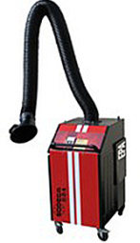
Be sure to always work in well-ventilated areas and by all means avoid inhalation of welding gases and fumes. If this is not possible, then you should take care that the workplace is equipped with appropriate ventilation devices. Dealing with the treatment of fumes is necessary and can be achieved in many ways.
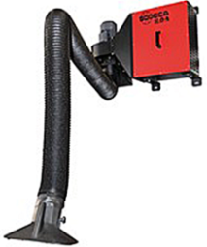

Image SEQ Εικόνα \* ARABIC 1 Portable and stationary ventilation device

The most widespread are (a) portable cantilever type devices, (b) permanent cantilever type devices, although less widespread and (c) personal devices.
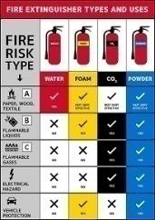
- Take all necessary precautions in order to avoid the risk of fire.
Avoid working near flammable materials, liquids or gases. Make sure there are devices suitable for dealing with fire in case of an accident and you know where they are in the area and how to use them.

- Constant control of the elements of the device through which current passes. This includes checking the insulation of TIG cables in order to avoid accidents (electric shock, fire, etc.).

- Do not operate TIG in a humid environment. Working in humid environments should be avoided to avoid electric shock.
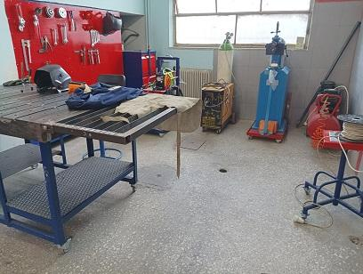

Image SEQ Εικόνα \* ARABIC 2 Welding workshop

- Finally, keep your device always clean and well maintained. When you're done, store your device in a clean, dry, and safe environment.

1.2 Personal protection measures
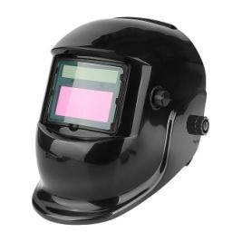
- Welding masks
The radiation emitted during welding (ultraviolet and infrared rays) can burn the eyes and skin. Always use an approved helmet during work.
The table below shows the degree of shading required in TIG welds depending on the operating volume.
Image SEQ Εικόνα \* ARABIC 3 E/S Mask
n/a | SHADING | TIG | MIG – MAG | MMA
1 | 8 | < 15 |  | < 100
2 | 9 | 15-75 |  | < 100
3 | 10 | 75-100 | < 200 | 100-300
4 | 11 | 100-200 | < 200 | 100-300
5 | 12 | 200-250 | > 200 | > 300
6 | 13 | 250-300 | > 200 | > 300
7 | 14 | 250-300 | > 200 | > 300
Table 1 Mask shading depending on the operating intensity of the TIG.

- Work clothes and other equipment.
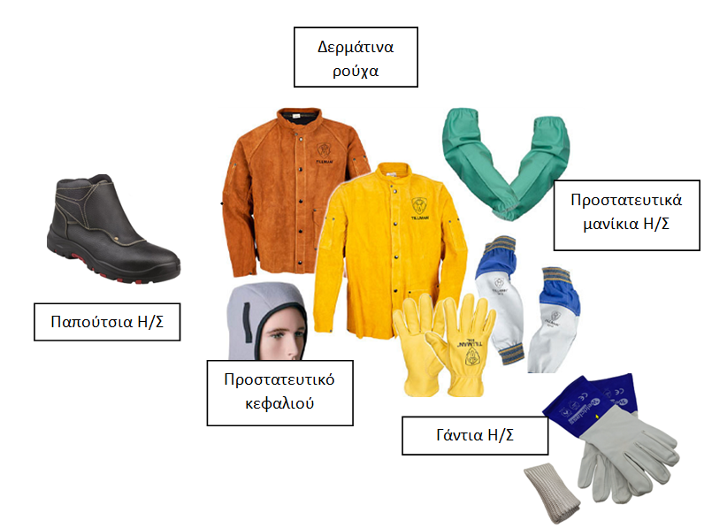
Make sure your work clothes, gloves and shoes are comfortable, mostly non-flammable and highly resistant to high temperatures.
Leather clothes

Protective sleeves

Welder shoes
Head protection
Gloves

2. INTRODUCTION TO TIG WELDING
2.1 Description of the TIG welding method
The idea of welding in a protected inert gas environment was developed in 1890. However, until the early 1900s, welding non-ferrous materials such as aluminum and magnesium remained quite difficult. These metals reacted chemically with air, resulting in bonding with pores and oxidation. In the early 1930s, inert gases were used in a flask. A few years later, a gas-shielded direct welding process arose in the aircraft industry to weld magnesium with a tungsten electrode and helium as a protective gas. Finally, the development of AC modules made it possible to stabilize the arc and produce high-quality aluminum and magnesium welds.

For this type of tungsten electrode welding by inert gas injection, the name (TIG) Tungsten Inert Gas has prevailed internationally. In America the same method is also called (GTAW) Gas Tungsten arc welding while in Germany we can meet it with the acronym (WIG) Wolfram Inert Gas, W (Wolfram). Later in this guide the method will be referred to by the acronym TIG.

Tungsten (Wolfram or Tungsten) is a metal with a melting point exceeding 33000C. This temperature is almost twice or more than the point of the materials we usually weld. This property makes it an ideal material for use as a non-consumable electrode in TIG welding.

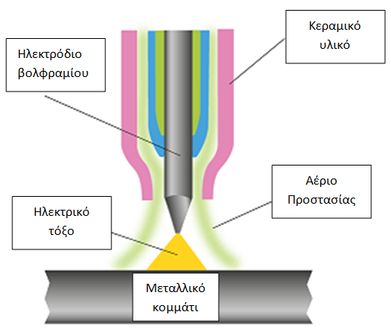
During the welding process using the TIG method, between the tungsten (non-consumable) electrode and the piece to be welded, an electric arc is generated which melts the pieces to be welded. In case additional material is needed to complete welding, then this is supplemented manually or automatically with special filler rods. At the same time, the area affected by heat (tungsten electrode and molten metal) is protected from oxidation or other air pollution through a protective shield created by the continuous supply of inert gas to the welding environment. The gases used are argon and helium which are neutral, do not react chemically with the welding environment and do not combine with other gases. They are also odorless and transparent, allowing maximum visibility to the welder.
Image SEQ Εικόνα \* ARABIC 4 TIG welding environment
Tungsten electrode
Ceramic material
Shielding gas
Electric ark
Metall piece

2.2 Where to use
TIG welding is often used for work that requires high-quality welding such as:
• In the marine industry and its applications
• Combined heat and power plants
• In the oil and gas industry
• In the food industry
• In the chemical industry
• In the nuclear industry
• Welding fine stainless steel materials
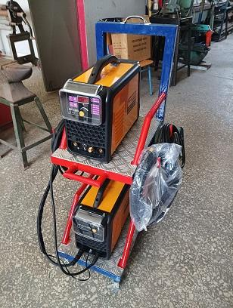
With the development of technology and autonomous, small economical materials it became possible to produce TIG welding devices, as a result of which they exist and are used in every machine shop, workshop, even for domestic use.
Image SEQ Εικόνα \* ARABIC 5 TIG device
It glues more types of metals and alloys than any other welding method. TIG welding machines can be used in welding steel, stainless steel, chrome steel, aluminum, alloys of nickel, magnesium, copper, bronze, brass, and even gold.

2.3 Advantages & Cons
A) Advantages of the TIG method
- Perfectly controlled and focused voltaic arc.
It thus allows control of the heat dissipated to the object, limiting the zone that will be affected.
- No sparks or splashes.
There are no melted splash material filings and no sparks are produced if the welded material is free of dirt.
- Less fumes compared to other welding methods.
However, base metals that are welded may contain coatings or elements such as lead, zinc, copper, and nickel that may produce hazardous fumes.
- It welds more metals and metal alloys than any other arc welding method.
- It is an ideal method for gluing laminates of small thickness.
- It provides the ability to weld dissimilar metals to each other.

B) Disadvantages of the TIG method
- The welding speed with the TIG method is less than other methods.
- Good specialization and experience are required for its proper use. Hand-eye coordination is a necessary skill.
- Brighter UV rays than other methods.
- The cost of equipment may be higher than with other methods.

 | TIG | WELDING O/A | E/S  MMA | E/S  MIG
Required skills | High | High | High | Middle
Quality of result | High specialization is required for a good result | High specialization is required for a good result | High specialization is required for a good result | Can be achieved with fewer skills
Thermal deformation | Middle | High | High | Low-medium
Equipment maintenance | Training required | Training required | Training required | Training required
Consumable parts | Least | Least | MMA electrodes | Wire  MIG
Table 2 Comparison of the TIG method with the other most common methods.

3. NECESSARY EQUIPMENT
3.1 The basic parts of a TIG assembly
The parts of which a TIG welding device is composed as shown in the figure below are:
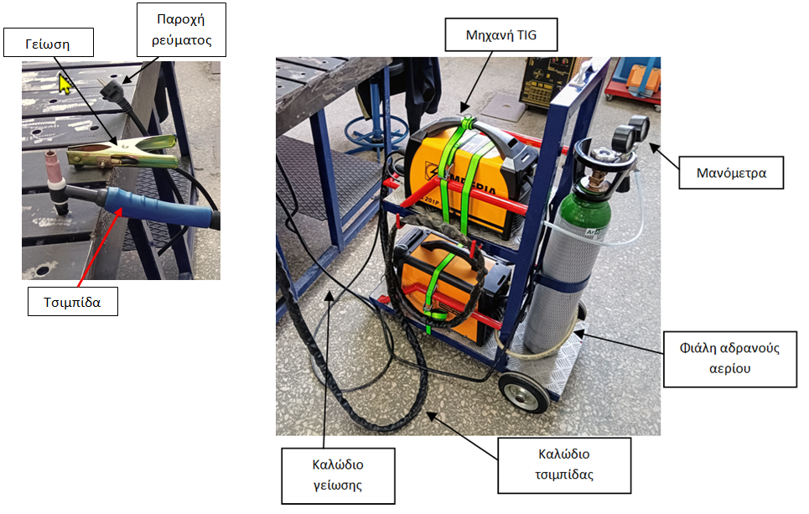

TIG machine
Power supply
groundinggggng

manometers

tongs

Innert gas bottle

Cable tongs
Ground cable

- The welding machine which provides the electricity necessary to light and maintain the voltaic arc.
- The protective gas cylinder with pressure gauges showing the gas content in the cylinder as well as the gas supply during the operation of the TIG.
- The welding torch (torch) and the wire connecting it to the welding machine. Through it, the necessary electricity and protective gas reach the tongs.
The tongs and ground wire that ensures the continuity of electric current to or from the machine. (It depends on the type of gluing).
- The controls of the machine through which the craftsman controls the lighting and maintenance of the voltaic arc. This can also be the pedal of the foot. It is referred to as optional because most devices have the control button on the welding torch.

3.1.1 TIG welding machine
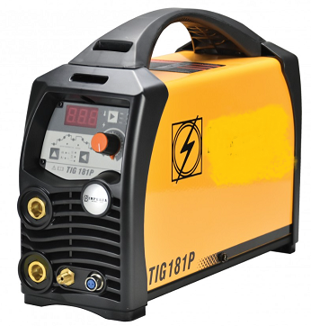
There are a huge number of TIG devices on the market and the craftsman welder has the ability to choose the most suitable one.
Image SEQ Εικόνα \* ARABIC 6 TIG Welding Machine
The factors that will influence its choice are
(a) Power and operating efficiency
(b) The duty cycle referring to the continuous welding that a machine can maintain before a cooling period is required
c) Quality, reliability and technical support (serviceability and repairability). Adequate technical support, spare parts availability and service centres in your area can significantly affect the productivity of welding operations.

The choice of current, as well as the intensity of operation with which the craftsman welder will work, depends on the material to be welded. The tables below show the type of current and polarity depending on the material and respectively the operating intensity depending on the type and thickness of the material.

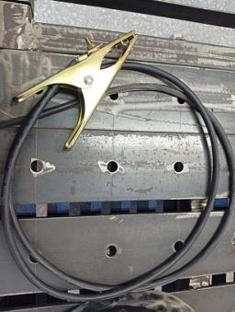
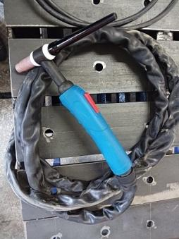
The TIG welding machine is always accompanied by the basic electrode tongs and grounding. The connection of the electrode and the ground in the welding machine depends on the type of material we will weld as shown in detail in the table below.

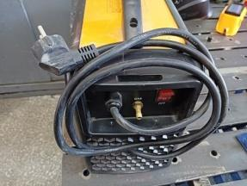
Finally, on the back of the camera is the mains power supply cable and the On/Off switch of the camera.

On/off switch

Material |  | Electricity / Polarity
Common and alloy steels  Copper and its alloys  Nickel and its alloys  Titanium and its alloys  Zirconium, tantalum, tungsten |  | - Setting Machine to DC (DC)  - We always connect the torch to the negative pole of the current source.
Aluminium and its alloys |  | Setting Machine to AC (AC)
Magnesium and its alloys |  | Setting Machine to AC (AC)
Table 3. Materials and electric current – polarity using Argon
Material  Thickness (mm) | Common and alloy steels |  | Aluminium and its alloys | Copper and its alloys
up to 2 | 120 A |  | 120 A | 200 A
up to 4 | 200 A |  | 200 A | 250 A
up to 6 | 250 A |  | 250 A | 300 A
Table 4. Selection of operating intensity in relation to the type and thickness of the material

3.1.2 Gas cylinders
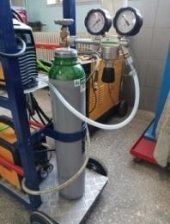
They are supplied in several sizes determined by the content of the bottle. It contains gas stored under pressure usually 230 to 300 bar and must be treated carefully. This gas protects the welding area from contaminants and enhances the welding process. The table below shows the inert gases used and some of their properties.
Image SEQ Εικόνα \* ARABIC 7 Argon bottle

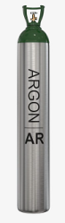  ARGON  - Good electrode lighting and field cleaning.  - Voltaic arc stability.  - Focused current cone.  - Good operation at low currents. | Argon/Helium mixture  - Improved welding speeds even from pure Argon  - Improved penetration  - Cleansing properties like Argon  - Welding arc cone highly focused.  - Higher cost than pure Argonne.
Helium
- Higher (2x) welding speeds.
- Increased penetration
- Difficult lighting
- Less good cleaning
- Less stability at low intensity
- Higher cost

Pin 5. Types and properties of protective gases

Gas | Material | Comments
Argon | Used in all materials | The most widespread
VARIGONHe 30 S | In the welding of aluminum and its alloys | It has stability and ensures proper lighting of the electric arc
VARIGON 30's  VARIGON 50's  VARIGON 70's  Hellion | Aluminium and its alloys  Copper and its alloys | Because higher temperatures are developing, we have:  - Better penetration  - Faster speed  There is difficulty ignition – ignition with Argon
VARIGON He 2  VARIGON He 5  VARIGON He 6  VARIGON 10 | Strong alloyed steels  Nickel and its alloys | Because higher temperatures are developing, we have:  - Better penetration  - Faster speed  To avoid creating resources
Table 6. Use of gases in relation to the material of the welded pieces.

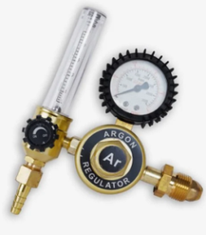
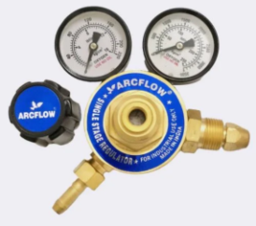
A necessary component of the TIG weld connected to each inert gas cylinder are the manometric expanders. The most common consists of two pressure gauges. One pressure gauge is high pressure and shows us the content of the bottle so that the operator can prepare for its replacement. The second is a low-pressure pressure gauge and this enables the operator to adjust the supply of protective gas from the bottle to the welding torch. In its other version, the low pressure pressure gauge can be replaced by a ball flow regulation device (flow meter).
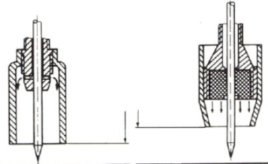
The mode of flow and the amount in L/min of the gas depends on the operating intensity, material and type of gas. It usually operates in a range of 5 – 12 L/min. The action and access of gas to the weld site can be improved by adding a special filter to the nozzle (Gas lens).

3.1.3 Torch - welding torch
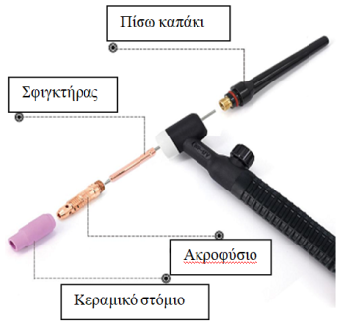
The basic parts of the tongs are:
Back cover
a) The orifice. (Ceramic spout)
clamp
Gas spouts are made of several types of heat-resistant materials in different shapes, diameters and lengths. The spouts are usually screwed to the body of the welding torch, but in some cases they are simply pressed into place. Spouts can be made of ceramic materials, glass or other materials. Ceramic is the most popular material, but it can easily break.

nozzle
Ceramic spout

b) The nozzle
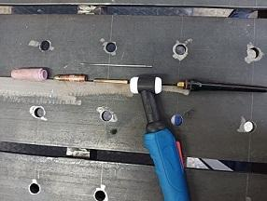
It is the component through which the protective gas passes and diffuses.
c) The clamp
Working with the nozzle and back cap fixes the tungsten electrode.
(d) The back cover.

The torch is perhaps one of the most critical components of a TIG welding device. It is the component in which the voltaic arc is created, resulting in receiving large amounts of heat. Because the operator is constantly in contact, it must be cooled systematically. This cooling is achieved mainly through the flow of the protective gas. In larger layouts, cooling occurs by circulating water.

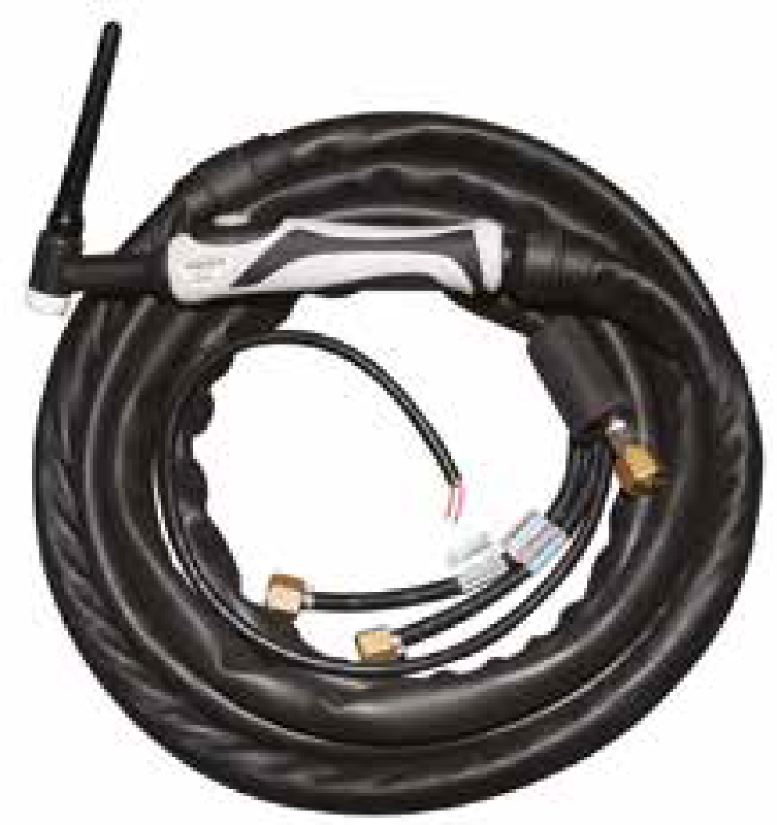
Finally, the control button with which the welder controls the switching on and off of the electric arc. There are two options for operating the machine. One is with the foot (foot pedal) and the other with the hand. In the second case, the controller is located on the tongs.
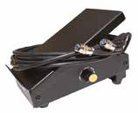

(a) Manual operation (b) Foot control

4. TUNGSTEN ELECTRODES
4.1 Standardization of tungsten electrodes
TIG welding electrodes as mentioned are made of tungsten with some impurities. This makes them particularly resistant to normal welding temperatures and "non-consumable" as they do not melt during welding.

Tungsten electrodes are marketed in several types, which are determined by a specific color. In order to improve the properties of tungsten, it is mixed with a number of chemical elements in specific percentages. In this way, new, improved, with better properties electrodes are obtained.

The most common oxides are mainly zirconium, thorium, lanthanum or cerium. These are usually added at a rate of 1% - 4%. The main reasons for the impurity are:
- Improving the current transfer capacity of the electrode
- Increasing the life of the electrode
- Increasing arc stability
- Improving the ability to ignite and maintain the electric arc.

In the table below we can see the characteristic colors of the electrodes, the type and percentage of the chemical element and which electrode we choose depending on the operating current.

Type of welding | Electrode type | Colour | Cerium  Lanthanum  Thorium  Zirconium  They are chemical elements that in appropriate impurities improve the properties of the electrode.
AC | Pure Tungsten | Green
DC or AC | Ceriated 2% | Gray
DC or AC | Lanthanated 1% | Black
DC or AC | Lanthanated 1,5% | Gold
DC or AC | Lanthanated 2% | Blue
DC | Thoriated 1% | Yellow
DC | Thoriated 2% | Red
AC | Zirconiated 1% | White
Pin 7. Electrode selection based on the type of welding

Tungsten electrodes, in addition to color standardization, are standardized based on their diameter. This for the most part determines the working intensity of the weld.

Diameter  Electrode | DC  Electrode at the negative pole | AC
1 mm | 15-80A | 10-80 A
1,6 mm | 70-150A | 70-150 A
2,4 mm | 150-250A | 140-225 A
3,2 mm | 250-400A | 225-325 A
4 mm | 400-500 A | 300-400 A
6 mm | 750-1000 A | 500-630 A
Table 8. Standard electrode diameters and operating intensity

When welding, contact of the electrode with the metal object, the melt pond and the additional adhesive should be avoided. The contact of the electrode with the above causes contamination of the electrode and results in reduced performance and gradually destruction of the electrode at the point of contact. As soon as the technician – welder detects such contact, he must immediately stop the work and clean the electrode with grinding.
4.2 Preparing electrodes for use
In addition to the correct choice of tungsten electrode, the next factor affecting the properties of the voltaic arc, the geometry of the seam, the proper functioning and service life of the electrode is the configuration of the spike. In addition to the geometry of the cone, great importance should be given to the quality of the surface so that it is always uniform and smooth.

The following general rule indicates the relationship between the diameter of the tungsten electrode and the length of the welding cone.
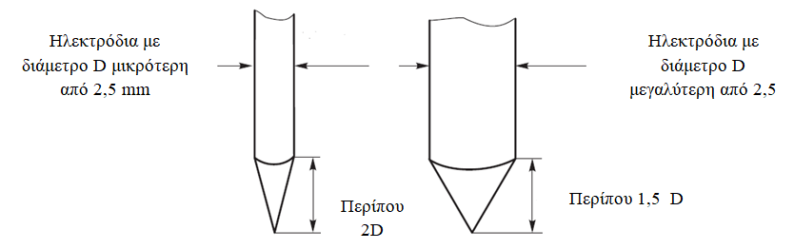
electrodes with a diameter D smaller than 2.5 mm
electrodes with a diameter D bigger than 2.5 mm

About 2D
About 1.5 D

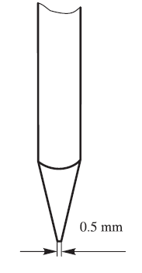
For deep penetration, pin angles with values between 30o – 60º are proposed. A small spike angle gives a narrower seam. As the angle of the spike increases, the width of the seam increases.

During the preparation – grinding of the electrode, we must consider the operating intensity of the machine. At low operating intensities the spike can be evenly grinded along its entire length. For larger values, however, creating a flat area in diameter d 0.5 mm can enhance arc stability and increase electrode life.

4.3 Electrode grinding
4.3.1 General instructions
When we grind our electrode, it is important to know in advance what we want the final result – shape to be. In general, it is true that the sharper the edge of the electrode, the wider the seam of the weld will be and the greater the stability in the electric arc. However, sharper electrodes have a shorter service life and less welding penetration.
Given that different grinding profiles produce different welding characteristics, the final shape of the electrode depends largely on the craftsman and the material to be welded. However, the following rule is strongly recommended: whichever profile-shape is chosen at the beginning of welding, with it must be completed. Otherwise, changing the shape of tungsten will lead to different profiles of seams.

In terms of safety, avoid inhaling tungsten dust and make sure you have proper safety equipment when sharpening or cutting your electrode.
4.3.2 Grinding apparatus and tools
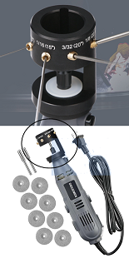
In the market there is a plethora of devices and tools used to shape and grind the cone (spike) of the electrode. These devices enable the craftsman to properly prepare the tungsten electrode, of any diameter and at whatever angle he decides is right for the job he is going to do.

Many times, however, the modulation – grinding of the electrode is done on conventional twin fixed wheels. In this case, it is advisable to use wheels for grinding hard materials, as tungsten is incredibly hard.

Image SEQ Εικόνα \* ARABIC 8 Grinding device

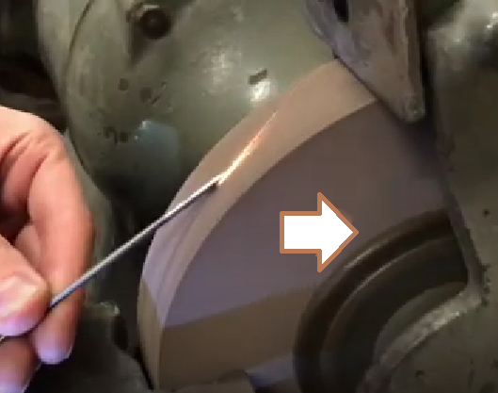
When a conventional wheel is used to grind the electrode, the craftsman must follow a specific path.
Image SEQ Εικόνα \* ARABIC 9 Twin wheel

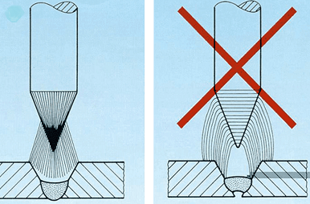
The vast majority of electrodes are made so that their granules run along. This means that when forming you need to hold the tungsten parallel to the grinding wheel. At the same time, the craftsman manually rotates the electrode until the completion of the process. This will result in grinding lines aligned with the grain geometry of the electrode. Otherwise, the grinding lines. They will be perpendicular to the axis of the electrode, so that the voltaic arc does not concentrate evenly at the point directed by the craftsman and makes the welding process difficult.

The grinding of the electrode on a wheel must be done with great care, since the craftsman with his experience determines both the geometry of the spike and the quality of the surface.
Image SEQ Εικόνα \* ARABIC 10 Avoid radial lines

5. TIG WELDING RODS

5.1 Standardization of TIG welding rods

In most applications of the TIG welding method, it is necessary to add additional adhesive in order to achieve a stable and safe welding. For this reason, there are standard welding rods or otherwise adhesive filler rods.
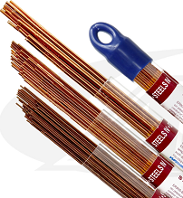
TIG filler rods are a key component in the welding process, since they complement the joining of the base pieces with additional adhesive. For this reason, the choice of filler rod greatly affects the quality and properties of welding.

The factors to consider when choosing the filling rod are mainly:
- The type of base metal or metals to be welded (carbon or stainless steel, aluminum, magnesium, etc.)
- The thickness of the base metal
- The welding position (flat, horizontal, vertical, etc.)
Image SEQ Εικόνα \* ARABIC 11 Welding rod packaging
- The desired properties of the final weld (e.g. corrosion resistance, ductility and tensile strength).
The material of which the filler rod is composed must be compatible with the properties of the base metal to ensure a strong and reliable bonding.

So, depending on the material to be welded, we also have the coding of the filling rods so that the craftsman welder can make the best possible choice.
- Basic material: common steel.
The ER70S series with different digits at the end is ideal for dealing with specific conditions of the metal (e.g. dirty or clean) or type of compound, e.g. ER70S-2, ER70S-6 and many other options.
- Basic material: stainless steel.
The ER308 & ER308L series is the choice for welding in stainless steel, widely used in construction.
The ER309 &; ER309L series is used for welding dissimilar metals. It can handle higher heat and has good corrosion resistance.
The ER316 & ER316L series is commonly used for pressure vessels, valves, chemical equipment and marine applications ("L" refers to extremely low carbon in the rod, less than 0.08%, which adds corrosion resistance).
- Basic material: aluminum.
The ER4043 series is a filler used in most aluminum welding applications.

Filling rods are usually commercially available in lengths of 1 or 2 m. Their diameter starts from 1.5 – 6 mm and they are packaged and sold in kilograms of Kg.
The table below provides indicative values for choosing a filling rod diameter relative to the rest of the parameters of welding. However, these values may need to be modified depending on the welder, welder and welding technique.
Seam thickness in (mm) | Electrode diameter in (mm) | Filling rod diameter in (mm) | Ceramic spout | Operating volume in (A) | Travel speed  in cm/min
1,6 | 1,6 | 1,5 | 4,5,6 | 95 - 135 | 40
3,2 | 1,6 -2,4 | 2 | 4,5,6 | 145 - 205 | 30
4,8 | 2,4 | 3 | 7,8 | 210 - 260 | 25
6,4 | 3,2 | 4 | 8,10 | 240 - 300 | 25
Pin. 9 Selection of welding rod thickness for ordinary steel.
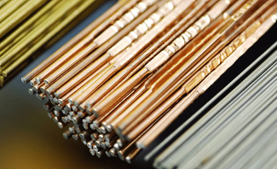
It is a fact that TIG welding is used for welding in a variety of materials such as copper, magnesium, nickel alloys and applications such as chemicals, aviation and aerospace, automotive, food industry, etc.

The above information regarding the rows of filling rods is given for indicative and educational purposes. The skilled craftsman should look for the ideal filling rod each time depending on the needs and requirements of the construction.
Image SEQ Εικόνα \* ARABIC 12Types of bars

In conclusion, choosing the right type of filler rod is of great importance to achieve a successful TIG welding. Each type of filling rod has specific properties and is suitable for specific applications. Knowing the different types of filling rods available can help you make a more informed decision to make the right choice according to your welding needs.

6. PREPARATION BEFORE USE
6.1 Welding configuration
The setup environment of a TIG welding varies from machine to machine, depending mainly on the manufacturer. However, the settings and functions are similar in all welds. Before starting the welding, each craftsman must consult the manufacturer's book that accompanies it, in order to know where it is and what is the destination of each part (switch, dimmer, etc.).
As soon as we open the main on/off switch of the camera, the screen on the front of the device lights up which will give us the possibility of specific options and settings.
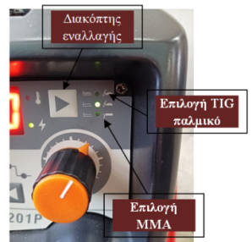
Toggle switch
- Select TIG, MMA. With the help of the radio button, we move the light and select the TIG mode continuous. The picture shows the toggle key and the other two options given by this camera, TIG pulse option and MMA (Manual Metal Arc welding) welding.
Option TIG pulse
Option MMA
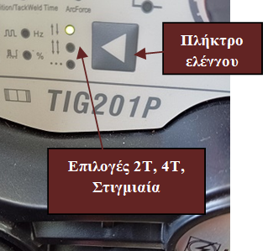
- Option 2T, 4T, Bet. Then we choose how to control the electric arc. We have three options: a) the arc lights up by pressing the switch and turns off when we release it (2T), b) the arc lights up when we press the switch, then we release it and when we finish, we press it to turn off. c) finally, the betting option.
Control key
Options 2T, 4Tmoment

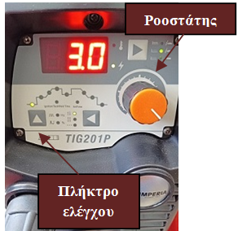
- Setting gas pre-flow time. With the control button we move to the first light indicator. With the dimmer we choose for how long before lighting the arc, we want the inert gas to spray the weld area. In this way we make a first cleaning and inactivation of the area.
Rheostat dimmer

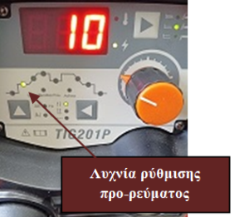
- Pre-current volume adjustment. This option allows us, by rotating the dimmer, to choose whether we want our machine to start (for a short time) with an intensity lower than the final one. A value of about 30-40% of the normal intensity is selected.
key

Pre current adjustment lamp

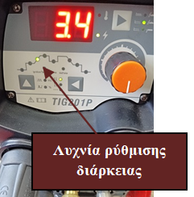
- Pre-current duration. With the radio key we move so that the light for adjusting the duration of the pre-current lights up. With the help of the dimmer, we select how many seconds we want our device to work in this state before passing to the volume of normal operation.
Duration adjustment lamp

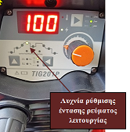
- Adjust the volume of normal operation of the TIG. We move to the next light in order to adjust the operating volume of the TIG. The craftsman, after taking into account the thickness of the metal pieces to be glued, selects the value of the intensity he wants with the help of the dimmer. He can intervene at any time and make corrections if he deems it necessary.
Operation current regulation lamp
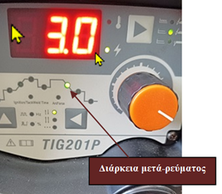
- Adjust after-current duration. With this adjustment, the craftsman chooses if he wishes, from the moment he releases the power button to stop welding, if there will be after-current and for how long. Selecting the lamp shown in the picture with the dimmer sets the time the voltaic arc will continue at a lower intensity.
Duration after current
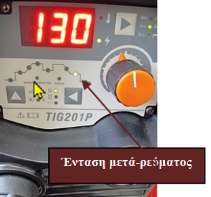
- After-current volume adjustment. By choosing the next lamp, the craftsman has the ability with the help of the dimmer to adjust the intensity of the electric arc before it is completely extinguished. As with pre-current, values of about 30% of the normal operating current are selected
Intensity after current
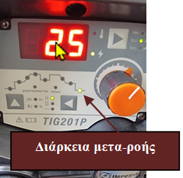
- Inert gas afterflow regulation. Spraying with inert gas after extinguishing the arc is a particularly important function. It enables the electrode to cool gradually over the weld area and cools the welding. The time can take values up to 9 sec and its price is determined by the craftsman.
Duration after flow

It is clarified that the purpose of this section is to explain the principle of operation and the basic principles concerning the initial settings of the TIG. The price adjustment and control buttons can be digital or analogue and vary from machine to machine.
We always consult the manufacturer's book.

6.2 Important instructions before use

TIG welding is an extremely useful and versatile method, through which we can weld many different metals. The biggest problem with TIG welding is that it requires more experience, technique and skill to achieve the intended result than most of the other welding methods.
This can be frustrating for artisan welders who attempt to take their first steps in learning this method.

Below are some basic instructions – tips that can help the craftsman make these first steps of learning the method easier.

- Get a comfortable working position. Ensure that during welding you get a comfortable and restful working position. This is the best way to get uniform and stable welds while reducing fatigue. Here are some guidelines that are often affected by the nature of welding. It is ideal to sit at work. Adjust the height of the seat relative to the welding table for a good and comfortable working position.
Make sure your hands and wrists don't come into contact with anything heated by welding.
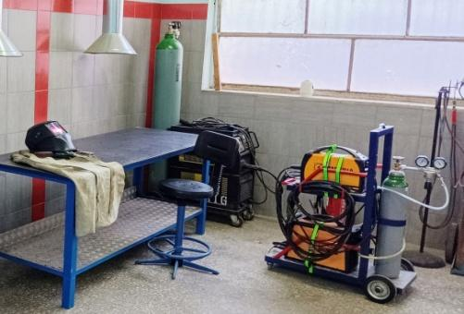

Image SEQ Εικόνα \* ARABIC 13 Standard TIG school lab layout.

- Good cleaning of tracks.
TIG welding due to tungsten does not forgive dirty material. You should always take the time to remove dirt, dust, oil, or other contaminants from the metal surface before you start.
In addition to cleaning surfaces with a solvent, some materials require additional preparation. E.g. soft steel will need to remove any rust coating while aluminium will need to remove the oxide layer with a stainless-steel wire brush.
If the material is not cleaned thoroughly, there is a risk of contamination of the electrode and welding. Even if the welding looks good, there can be serious errors under the surface, making welding ineffective.

- Choose the right type of electrode. There are many types of tungsten electrodes to choose from. Choosing the right electrode is one of the most important steps before starting a weld. In section 4. of the laboratory guide there is all the necessary information to make the right choice.
- Pay attention to the angles of work with the welding torch

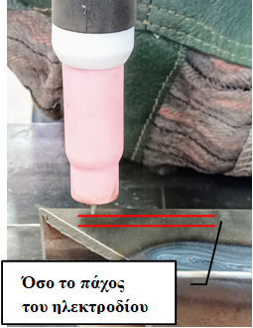
With the welding torch we create the electric arc and direct the heat to the desired point. The position of the torch determines the distance and orientation that the tungsten electrode will have with the welding environment.
The first thing to pay attention to is the distance of the electrode from the metal surface. We place the electrode on the surface of the object and then move it away at a distance as far as its diameter.
As much as the thickness of the electrode
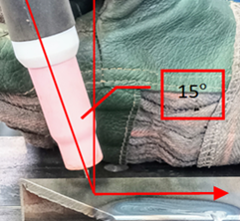
Then we give the tongs from a vertical position a slope of 15o opposite the direction of travel.
The angle of the electrode is important because it ensures good visibility at the weld point as well as access to the molten metal lake to add adhesive.

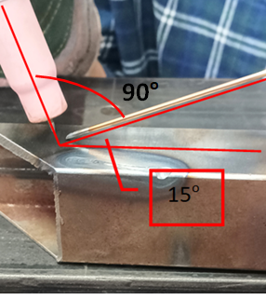
The geometry of welding by filling in adhesive is shown in the adjacent figure. We distinguish the filling wire and the angle of 15o degrees it should have from the plane of the welding surface or table. Given that we have already tilted our tongs 15o, we notice that between the tongs and the filling material we try to maintain an angle of 90°.

It goes without saying that in pipe welding, welding of internal and external angles, type T, the geometry varies as needed.

- Beware of electrode contamination.
Tungsten is a particularly sensitive material that during welding is protected from the environment by inert gas. By adjusting pre-flow and post-flow we ensure that, before, during welding and shortly after (i.e. as long as it is hot) we do not allow it to come into contact with ambient air.
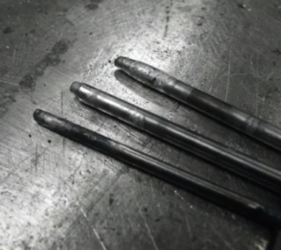
Another aggravating factor is the contact of tungsten with the surface of the piece, the lake of molten metal or the filler. Although we want our electrode to be as close as possible to the weld point, we must be careful and always maintain a constant distance that prevents contact. One of the immediate consequences is a drop in arc stability. The craftsman welder must immediately stop work and grind the electrode from scratch.

- Smooth movement and stable welding speed
Because during welding with the TIG method molten metal is highly fluid, any slight displacement, shaking or trembling of the hands is transferred to the seam of the weld. Of course, keeping our hands steady is a challenge and can only be achieved through continuous training that results in muscle memory.
But before writing down the necessary kilometers of adhesive seams, we can make a little preparation.
- Try to make the route of welding with the machine closed. This way your hands will learn the route and you will see which points need attention.
- Try to keep the angle of the electrode constant and avoid sudden changes in speed. Keep all your movements gradual and smooth.
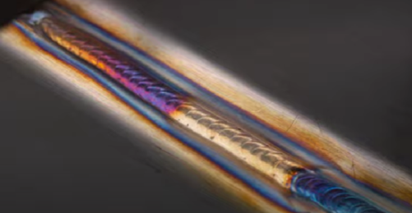
- The secret to a stable and uniform thickness along the entire length of the weld seam is to maintain a constant speed along its entire length. You will easily notice that any change in travel speed is directly reflected in the final result.
- But in addition to the uniformity and quality of the seam, the amount of heat attributed to the base metal will also differ, as a result of which the amplitude of deformation will differ.
Image SEQ Εικόνα \* ARABIC 14 Thermal deformation
- Daily practice.

LABORATORY EXERCISES
EXERCISE NO. 1
‘Disassembly & Assembly of the welding torch (Electrode torches)’
Objectives pursued
After carrying out the exercise, students should be able to:
- Identify and name the parts of which the electrode tongs are composed.
- Disassemble and assemble the tweezers in the correct order.
- Inspect and replace worn parts.
Introductory information
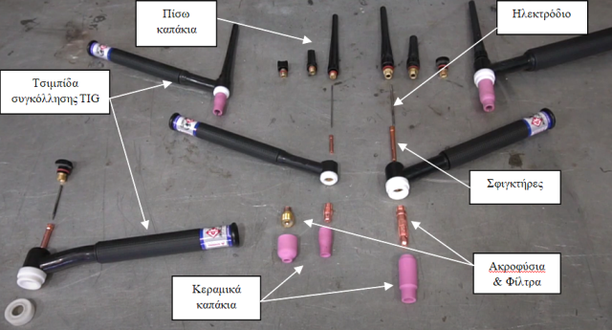
Electrode tongs are one of the most basic components of a TIG welding. The parts of which it is composed are:
Back caps
electrode
A) The ceramic orifice

TIG welding tweezers
B) Nozzles & filters
C) Clamps
clamps
D) Tungsten electrode
ceramic orifice
Nozzles filters

E) Rear plastic caps
Means, materials and equipment required.In order to perform the exercise, the following are required:
(a) Plastic back caps of different lengths
b) Tweezers of the electrode
(c) Series of ceramic orifices
d) Nozzles and filters
(e) Clamps and electrodes of different diameters
f) Flat and clean workbench. The welding table can be used.

Course of work

- We screw the nozzle to the body of the tweezers. In this, as well as the next steps, attention needs to be paid to tightening the parts. Tightening should be done gently with both fingers. No exaggerations! | 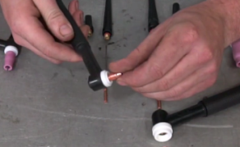
- On the back of the body we place the sphincter. It is important to have chosen a clamp corresponding to the diameter of the electrode. Eg. For an electrode with a diameter of 3.2mm we choose a clamp of 3.2mm. | 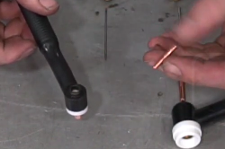
- We screw the plastic back cap without tightening it completely. As shown in the picture in the introductory information, their lengths differ. The choice of length is made depending on the length of the tungsten electrode. | 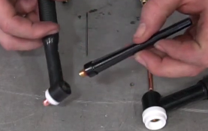
- We carefully pass the electrode through the nozzle and clamp. Attention, the end that will be left on the free side must be the one that has been grinded and shaped properly for welding. | 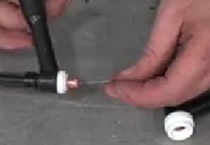
- We select the ceramic spout to use and carefully screw it to the body of the tongs. The characteristic number will determine the free length of the electrode. | 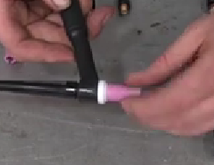
- Unscrewing the back cap releases the electrode and we can adjust its free length. For example, if the ceramic spout has the number 7, it means that its inner diameter is 7/16 ́ ́ of an inch, about 11mm. We screw the back cap and the tongs are ready for use. | 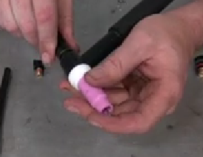
- Follow the reverse procedure in order to disassemble the torches.

EXERCISE NO. 2
‘TIG operation configuration’

Objectives pursued
After carrying out the exercise, students should be able to:
- Adjust the operating parameters of a TIG according to the thickness of the material and the diameter of the electrode.
Introductory information
On the front of a TIG PC there is the main screen of the device and the buttons with which we can choose the ideal conditions for the operation of the machine. (More information in Chapter 5, section 5.1.)
In these settings we should take into account that we will use a 1.5% Lanthanated electrode, with gold marking and a diameter of 2.4mm. Also the test piece will be made of common carbon steel with a thickness of 2mm.

Means, materials and equipment required. In order to perform the exercise, the following are required:

a) TIG PC device
b) Tweezers of the electrode with Lanthanated 1.5% electrode, with gold marking and diameter 2.4mm.
c) Flat and clean workbench. The welding table can be used.
(d) The manufacturer's book.
(e) 100 x 40 x 2 mm steel specimen.

Course of work

- We connect the power supply cable to the network and bring the switch to the on position. | 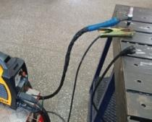
- Using the move button we select the TIG mode. Make sure that the TIG function indicator light is on. | 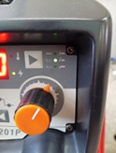
- We move the light to the pre-flow setting and with the dimmer we select the inert gas to start 3sec before the voltaic arc lights up. This will make a first cleaning and inactivation of the welding environment. | 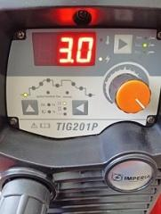
- Then we set the starting current to 40A as well as the time the machine will operate at this value of intensity 3sec. | 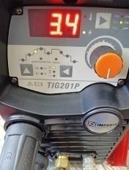
- The normal operating volume of the machine is set to 100A. | 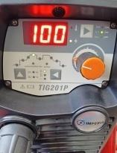
- We set the shut-off current to 40A as well as the time the machine will operate at this value of 3sec | 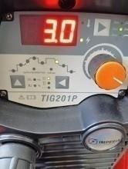
- We move the light to the flow setting and with the dimmer we select the inert gas to continue flowing 2.5sec after the voltaic arc goes out. This will help cool the electrode and weld and avoid contamination. | 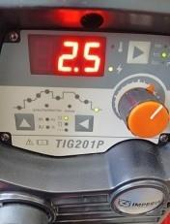
- Finally, for the control of the electrode we select the 2T mode. This means that the electrode will turn on when we press the switch and will turn off when we release it. | 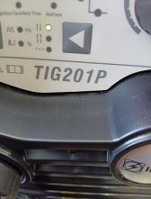
- The machine is ready for use and you can do the first tests. Any change in the arrangements can also be made during the works.
You can change the settings by checking the results each time.

EXERCISE NO. 3
‘Inert gas flow adjustment of a TIG power station depending on the thickness of the material and the diameter of the ceramic orifice’
Objectives pursued
After carrying out the exercise, students should be able to:
- Regulate the flow rate of inert gas according to the diameter of the ceramic orifice and the working conditions.
Introductory information
The cylinder contains gas stored at a pressure of usually 230 to 300 bar.At the top of the inert gas cylinder is the set of manometers. The most common consist of two manometers. One pressure gauge is high pressure and shows us the content of the bottle so that the operator can prepare for its replacement. The second is a low pressure gauge and enables the operator to adjust the flow rate of the protective gas in L/min from the cylinder to the welding torch.

Means, materials and equipment required. In order to perform the exercise, the following are required:

a) TIG PC device
b) Ceramic spout welding tongs No. 6.
(c) Inert gas cylinder with connected manometers.
d) Flat and clean workbench. The welding table can be used.

Course of work
- Before any work, we thoroughly check the condition of the pipe that carries the inert gas from the bottle to the device. Before the operation of the TIG welding we must make sure that there is no leakage and the gas flow is unhindered. | 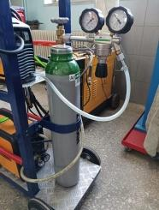
- We make sure that the readings on both manometers are zero. We open the valve of the bottle counterclockwise. | 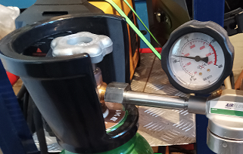
      - We check and mark the reading of the high pressure manometer. This indicator shows us the content of the inert gas in the flask.

- We rotate the pressure regulator clockwise while checking the change in the reading of the low pressure pressure manometer. Set the inert gas flow rate to 10 l/m. In general, a flow rate twice as large as the numerical marking of the orifice is chosen. | 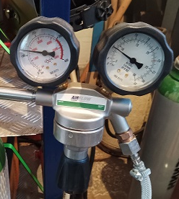
- On the electrode tongs press the power switch to release inert gas. We check the deviation on the low pressure gauge and if necessary make the necessary corrections. | 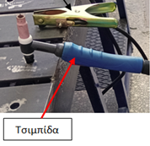  tongs
      - This arrangement may not be final. During the operation and performance of the engine, the fitter may judge that he must increase the flow rate or decrease it in order to reduce gas consumption.

EXERCISE NO. 4
‘Formation of melting points by TIG welding, without and with the addition of adhesive’
Objectives pursued
After carrying out the exercise, students should be able to:
- Create and maintain the correct geometry (angles) of the electrode torch during work.
- Light, control and direct the voltaic arc to the point of welding in instantaneous operation (staking).
- Properly handle and direct the filler rod into the pond of molten material.
Introductory information
Based on the thickness of the metal plate, the diameter of the electrode and the ceramic spout we will make the adjustments of the volume of normal operation and the supply of the protective gas.
Before welding, the sheet must be cleaned very well so that it is free from rust, oils or other fatty substances that will contaminate the electrode and reduce the welding performance and the quality of the result.
            - We set the operating volume to 125A.
            - We choose ceramic spout 7.

Means, materials and equipment required. In order to perform the exercise, the following are required:

a) TIG PC device
b) Steel metal plate measuring 100x 40 x 4mm.
c) Welding rod TIG thickness 2mm type ER70S-2 with diameter 2mm.
d) Flat and clean workbench. The welding table can be used.
(e) 2,4mm tungsten electrode.

Course of work
- On the metal plate 100x 40 x 4mm we will draw vertical and horizontal straight lines parallel to each other that will be 10mm apart. Then we will bet the intersection points of the straights. | 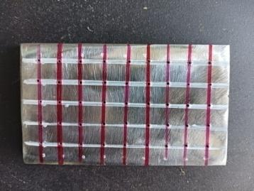
- We place the electrode on the point where we will make the first point. We lift the electrode and give the necessary inclination of 15⁰. | 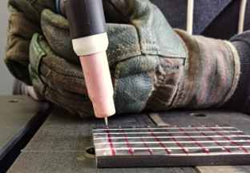
- We press the electric arc ignition switch and wait to see a lake of molten metal formed at the point. Once this is done, let the switch turn off the electric arc.  Be careful not to remove the electrode from the site until it cools down, otherwise the tungsten electrode is contaminated by atmospheric air.  Repeat the process at all points of the metal plate, omitting one vertical line at a time. | 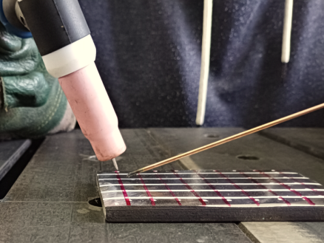
      - At the points of the laminate that we have omitted in the previous work, we will make instant welding with adhesive supplementation.

      - We press the electric arc ignition switch and wait to see a lake of molten metal formed at the point. Once done, we approach the filling stick and dip it in the melt pond. Remove the stick and let the switch turn off the electric arc.

Attention!!! The tungsten electrode should not come into contact with either the welding rod or the pieces. In case this happens, the welder must stop the process and grind the electrode again.

EXERCISE NO. 5
‘Melting line formation by TIG welding, without addition of adhesive’
Objectives pursued
After carrying out the exercise, students should be able to:
- Maintain the prescribed distance between electrode and laminate.
- Create and maintain during operation the correct geometry (angles) of the electrode torch.
- Light, control and direct at constant speed, the voltaic arc to the point of welding.
Introductory information
Based on the thickness of the metal plate, the diameter of the electrode and the ceramic spout we will make the adjustments of the volume of normal operation and the supply of the protective gas.
Before welding, the sheet must be cleaned very well so that it is free from rust, oils or other fatty substances that will contaminate the electrode and reduce the welding performance and the quality of the result.
            - We set the operating volume to 125A.
            - We choose ceramic spout 7.

Means, materials and equipment required. In order to perform the exercise, the following are required:

a) TIG PC device
b) Steel metal plate measuring 100x 40 x 4mm.
(c) Angle electric grinder.
d) Flat and clean workbench. The welding table can be used.
(e) 2,4mm tungsten electrode.

Course of work
- On the metal plate 100x 40 x 4mm we will draw horizontal straight lines parallel to each other that will be 10mm apart. The marking can also be done with an engraving tool, but at this stage we choose a marker to make the lines easier to see.  - We ensure a comfortable and relaxing working position.  - We make the welding route without current and highlight the points that will make it difficult for us. | 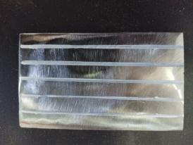
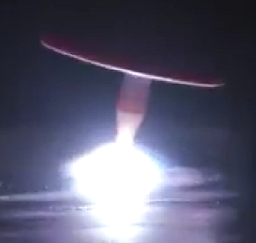
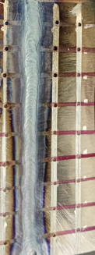
      - We press the electric arc ignition switch and wait to see a lake of molten metal formed at the point. Once this is done, we continue in the welding direction, maintaining constant distance from the laminate and the speed of movement. When we reach the edge of the lamella, let the switch turn off the electric arc.

Be careful not to remove the electrode from the site until it cools down, otherwise the tungsten electrode is contaminated by atmospheric air.

Repeat the process on all the lines drawn.
- The plate of the adjacent image shows the back of the specimen. The route highlighted in yellow maintained the correct travel speed. On the route marked in black, movement was slower.  As a result, we have a larger zone that has been affected by heat.  The zone affected does not depend on the operating intensity, ONLY on the speed of the welding stroke. | 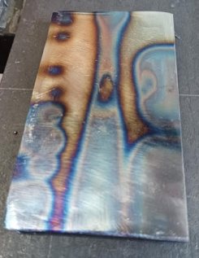

EXERCISE NO. 6
‘Melting line formation by TIG welding, with the addition of adhesive’

Objectives pursued
After carrying out the exercise, students should be able to:
- Maintain the prescribed distance between electrode and laminate.
- Create and maintain during operation the correct geometry (angles) of the electrode torch.
- Light, control and direct at constant speed, the voltaic arc to the point of welding.
- Correctly direct the welding rod into the pond of molten metal.
- Check the quality of welding.
Introductory information
Based on the thickness of the metal plate, the diameter of the electrode and the ceramic spout we will make the adjustments of the volume of normal operation and the supply of the protective gas.
Before welding, the sheet must be cleaned very well so that it is free from rust, oils or other fatty substances that will contaminate the electrode and reduce the welding performance and the quality of the result.
            - We set the operating volume to 125A.
            - We choose ceramic spout 7.

Means, materials and equipment required. In order to perform the exercise, the following are required:

a) TIG PC device
b) Steel metal plate measuring 100x 40 x 4mm.
c) Welding rods TIG type ER70S-2 with a diameter of 2mm.
d) Flat and clean workbench. The welding table can be used.
(e) 2,4mm tungsten electrode.

Course of work
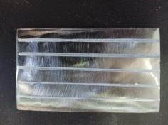
            - On the metal plate 100 x 40 x 4mm we will carve horizontal straight lines parallel to each other that will be 10mm apart.

- We ensure a comfortable and relaxing working position. We make the welding route without current and highlight the points that will make it difficult for us. | 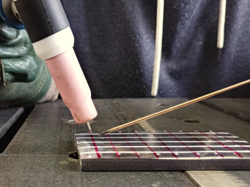
- We press the electric arc ignition switch and wait to see a lake of molten metal formed at the point. Once this is done, we continue in the welding direction while periodically immersing the TIG welding rod into the lake of molten metal.  Attention!!! The tungsten electrode should not come into contact with either the welding rod or the pieces. In case it happens, the welder must stop the process and grind the electrode again. | 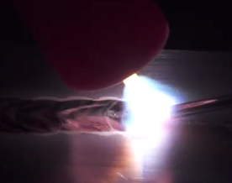
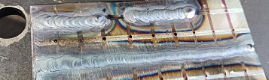
      - During the work we keep the distance to the laminate and the speed of movement constant. When we reach the edge of the lamella, we leave the switch to turn off the electric arc and keep the electrode at the point until it cools down.

Repeat the process on all the lines drawn.

Be careful not to remove the electrode from the site until it cools down, otherwise the tungsten electrode is contaminated by atmospheric air.

From time to time, we check the quality of the seam and make the necessary corrections.

EXERCISE NO. 7
‘Welding TIG head-on, horizontally with the addition of adhesive material’

Objectives pursued
After carrying out the exercise, students should be able to:
- Carry out frontal welding on flat metal sheets with the addition of a welding rod.
- Light, control and direct at constant speed, the voltaic arc to the point of welding.
- Correctly direct the welding rod into the pond of molten metal.
- Check the quality of welding.
Introductory information
Based on the thickness of the metal plate, the diameter of the electrode and the ceramic spout we will make the adjustments of the volume of normal operation and the supply of the protective gas.
Before welding, the sheet must be cleaned very well so that it is free from rust, oils or other fatty substances that will contaminate the electrode and reduce the welding performance and the quality of the result.
            - We set the operating volume to 125A.
            - We choose ceramic spout 7.

Means, materials and equipment required. In order to perform the exercise, the following are required:

a) TIG PC device
b) Two steel plates measuring 100x 40x2mm.
c) Welding rods TIG type ER70S-2 with a diameter of 2mm.
d) Flat and clean workbench. The welding table can be used.
(e) 2,4mm tungsten electrode.

Course of work
- We lay the lamellae frontally on the welding table.  - We ensure a comfortable and relaxing working position.  - We make the welding route without current and highlight the points that will make it difficult for us.  - We make small welding points in order for the lamellae to remain stable. | 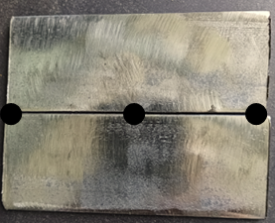
            - We press the electric arc ignition switch and wait to see a lake of molten metal formed at the point. Once this is done, we continue in the welding direction while periodically immersing the TIG welding rod into the lake of molten metal.
Attention!!! The tungsten electrode should not come into contact with either the welding rod or the pieces. In case it happens, the welder must stop the process and grind the electrode again.

- During the work we keep the distance to the laminate and the speed of movement constant. When we reach the edge of the lamella, we release the switch to turn off the electric arc and keep the electrode on the spot until it cools down. | 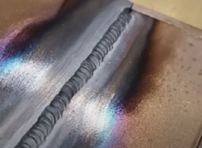
      - Finally, we check the quality of the seam and observe the surface affected by heat. We are making the necessary corrections.

EXERCISE NO. 8
‘External angle TIG welding without the addition of adhesive’

Objectives pursued
After carrying out the exercise, students should be able to:
- Weld metal sheets at an external angle 450
- Create and maintain during operation the correct geometry (angles) of the electrode torch.
- Light, control and direct at constant speed, the voltaic arc to the point of welding.
- Check the quality of welding.
Introductory information
Based on the thickness of the metal plate, the diameter of the electrode and the ceramic spout we will make the adjustments of the volume of normal operation and the supply of the protective gas.
Before welding, the sheet must be cleaned very well so that it is free from rust, oils or other fatty substances that will contaminate the electrode and reduce the welding performance and the quality of the result.

Means, materials and equipment required. In order to perform the exercise, the following are required:

a) TIG PC device
b) Two steel plates measuring 100x 40x2mm.
c) Flat and clean workbench. The welding table can be used.
d) Tungsten electrode 2,4mm.

Course of work
- We lay the lamellae frontally on the welding table.  - We ensure a comfortable and relaxing working position.  - We make the welding route without current and highlight the points that will make it difficult for us. | 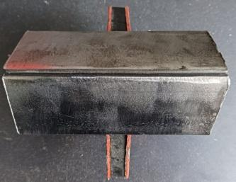
- We make small welding points in order for the lamellae to remain stable during the process of normal welding. | 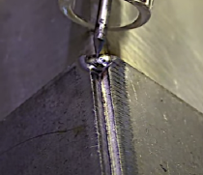
            - We press the electric arc ignition switch and wait to see a lake of molten metal formed at the point. Once this is done, we continue in the welding direction, keeping the speed of movement constant.

            - During the work we keep the distance to the laminate and the speed of movement constant. When we reach the edge of the lamella, we release the switch to turn off the electric arc and keep the electrode on the spot until it cools down.

Be careful not to remove the electrode from the site until it cools down, otherwise the tungsten electrode is contaminated by atmospheric air.
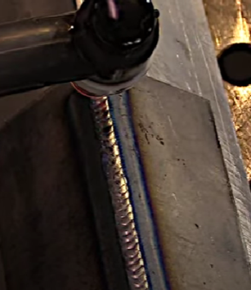
            - Finally, we check the quality of the seam and observe the surface affected by heat. We are making the necessary corrections.

EXERCISE NO. 9
‘External angle TIG welding with the addition of adhesive’

Objectives pursued
After carrying out the exercise, students should be able to:
- Weld metal sheets at an external angle of 450 with the addition of a welding rod.
- Light, control and direct at constant speed, the voltaic arc to the point of welding.
- Correctly direct the welding rod into the pond of molten metal.
- Check the quality of welding.
Introductory information
Based on the thickness of the metal plate, the diameter of the electrode and the ceramic spout we will make the adjustments of the volume of normal operation and the supply of the protective gas.
Before welding, the sheet must be cleaned very well so that it is free from rust, oils or other fatty substances that will contaminate the electrode and reduce the welding performance and the quality of the result.

Means, materials and equipment required. In order to perform the exercise, the following are required:

a) TIG PC device
b) Two steel plates measuring 100x 40x2mm.
c) Welding rods TIG type ER70S-2 with a diameter of 2mm.
d) Flat and clean workbench. The welding table can be used.
(e) 2,4mm tungsten electrode.

Course of work

            - We mount the lamellae at an angle of 450 on the welding table.
- We ensure a comfortable and relaxing working position.
- We make the welding route without current and highlight the points that will make it difficult for us.

            - We make small welding points in order for the lamellae to remain stable during the process of normal welding.

            - We press the electric arc ignition switch and wait to see a lake of molten metal formed at the point. Once this is done, we continue in the welding direction while periodically immersing the TIG welding rod into the lake of molten metal.
Attention!!! The tungsten electrode should not come into contact with either the welding rod or the pieces. In case it happens, the welder must stop the process and grind the electrode again.
- During the work we keep the distance to the laminate and the speed of movement constant. When we reach the edge of the lamella, we leave the switch to turn off the electric arc and keep the electrode at the point until it cools down.  Be careful not to remove the electrode from the site until it cools down, otherwise the tungsten electrode is contaminated by atmospheric air. | 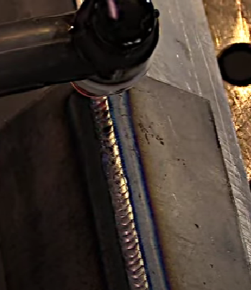
            - Finally, we check the quality of the seam and observe the surface affected by heat. We are making the necessary corrections.

EXERCISE NO. 10
‘Inner corner TIG welding with the addition of adhesive material’

Objectives pursued
After carrying out the exercise, students should be able to:
- Weld at an internal angle of 450.
- Light, control and direct at constant speed, the voltaic arc to the point of welding.
- Correctly direct the welding rod into the pond of molten metal.
- Check the quality of welding.
Introductory information
Based on the thickness of the metal plate, the diameter of the electrode and the ceramic spout we will make the adjustments of the volume of normal operation and the supply of the protective gas.
Before welding, the sheet must be cleaned very well so that it is free from rust, oils or other fatty substances that will contaminate the electrode and reduce the welding performance and the quality of the result.

Means, materials and equipment required. In order to perform the exercise, the following are required:

a) TIG PC device
b) Two steel plates measuring 100x 40x2mm.
c) Welding rods TIG type ER70S-2 with a diameter of 2mm.
d) Flat and clean workbench. The welding table can be used.
(e) 2,4mm tungsten electrode.

Course of work
- We mount the lamellae at an angle of 450 on the welding table.  - We ensure a comfortable and relaxing position.  - We make the welding route without current and highlight the points that will make it difficult for us. | 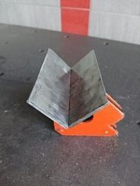
- Before starting work, we place on the tongs of the electrode a ceramic spout with the numerical marking 4. This is because the smaller diameter of the ceramic orifice will allow us to go closer to the position we will weld.  - We make small welding points in order for the lamellae to remain stable during the process of normal welding. | 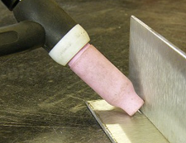
- We press the electric arc switch and wait to see a lake of molten metal formed at the site. Once this is done, we continue in the welding direction while periodically immersing the TIG welding rod into the lake of molten metal.  Attention!!! The tungsten electrode should not come into contact with either the welding rod or the pieces. In case it happens, the welder must stop the process and grind the electrode again. | 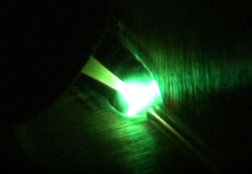
- During the work we keep the distance to the laminate and the speed of movement constant. When we reach the edge of the lamella, we release the switch to turn off the electric arc and keep the electrode on the spot until it cools down.  Be careful not to remove the electrode from the site until it cools down, otherwise the tungsten electrode is contaminated by atmospheric air. | 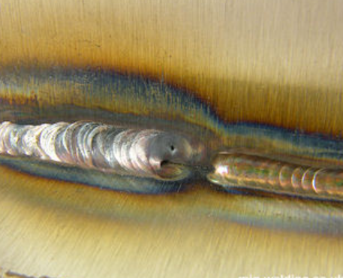
      - Finally, we check the quality of the seam and observe the surface affected by heat. We are making the necessary corrections.

SOURCES – BIBLIOGRAPHY

What is TIG Welding? (GTAW)
https://youtu.be/uO5pVLOAmD4?si=SblqjPhzsRhf7yy7
How to TIG weld (basic parameters explained)
https://youtu.be/9BH6DDD1RY0?si=E53l_7Guta2dUvWs
TIG Welding Tips and Techniques
https://youtu.be/tNYmo2_DI6c?si=umWXYSplS5iH3EGX
TIG Welding - Puddle Control
https://youtu.be/Vfhz9anpaWE?si=1d3YPRiRTiqMSoFc
TIG Welding 101_ An All Inclusive Introduction to GTAW
https://youtu.be/gCCdiksvXMU?si=NUJSFh_rOlsMosEQ
BASIC TELWIN TECHNOLOGY TIG SETTINGS (G.D. GUMASA.E.B.E.)
https://youtu.be/uAWrqiIhyNU?si=0qphBa_9iZ3iRsFQ
ΒΑΣΙΚΕΣΡΥΘΜΙΣΕΙΣ TELWIN INFINITY TIG 225 DC-HF/LIFT VRD - GKOUMAS S.A. (Γ.Δ. ΓΚΟΥΜΑΣΑ.Ε.Β.Ε.)
https://youtu.be/wZiLvHlrfoE?si=Mmq4CZylb_T-dlBt

ΒΑΣΙΚΕΣΡΥΘΜΙΣΕΙΣ TELWIN TECHNOLOGY TIG 230 DC-HF/LIFT VRD - GKOUMAS S.A. (Γ.Δ. ΓΚΟΥΜΑΣΑ.Ε.Β.Ε.)
https://youtu.be/vao-obfTWnQ?si=baCnDWccjMZiGz-I
https://www.mig-welding.co.uk/
Gas tungsten Arc Welding (GTAW) or (TIG) Welding pdf
TIG welding – Theory and practice. LINDEELLASEPE. pdf
TIG welding – Method and Application pdf

INDIAN RAILWAYS
HANDOUT FOR MECHANICAL ENGINEERING DEPARTMENT
TIG WELDING pdf
TECHNICALSPECIFICATIONSFOR TIG WELDING - www.CKWORLDWIDE.com

Guide to TIG weld - http://www.r-techwelding.co.uk

GUIDE TO TIG WELDING – https://www.wilkinsonstar.com/

