Program:
2023-2-TR01-KA210-VET-000182985

Erasmus+ KA 210

Strategic Partnership Programme in Vocational Education and Training

Programme Title:

“Innovative Methods in Teaching And Learning Welding in Vocational Education And Training”

" InnoWeld "

Gas welding module

Gas Welding Educational Material

TRAINING OBJECTIVES
The primary objective of this course is to ensure that participants in the training acquire the skills to proficiently perform gas welding tasks based on technical documentation. They should be able to complete welding tasks independantly and utilize the most modern technologies to assist their work. Additionally, participants will learn about the characteristics and interrelations of gas welding and understand the operation of the tools used in the process.

I/1. Topics of the course and number of hours per year:
Topics | Hours
The concept and essence of gas welding | 1
Gas welding equipment | 2
Welding gases | 2
Welding flame | 2
Gas welding technology | 50
Adjustment of welding flame | 4
Welding process | 52
Joints, fits, and weld types in gas welding | 10
Weldability of metals using gas welding | 2
Deviations and defects in weld joints | 1
Safety techniques in gas welding | 1

I/2. Skills to be developed during the course:

Skills and Abilities | Knowledge | Independence and Responsibility | Expected Behavior and Attitudes | General and Professional Digital Competencies
Interprets documents related to the task, purpose, and technology | Knows technical documentation | Completely independent | Dedicated to safe work practices, adheres to safety, fire, and environmental regulations. Executes precise and accurate welding. Strives to apply the best solutions while following the rules. Maintains a clean and organized work environment | Searches, browses, filters, uses, organizes, and shares digital content
Prepares for gas welding tasks based on technical drawings and plans, interprets information related to general mechanical materials and parts | Possesses basic material science and technical drawing knowledge | Completely independent | Same as above | Same as above
Prepares for gas welding tasks based on technical drawings and plans, interprets information related to general mechanical materials and parts | Knows the operation and construction of gas welding equipment | Completely independent | Same as above | Same as above
Skills and Abilities | Knowledge | Independence and Responsibility | Expected Behavior and Attitudes | General and Professional Digital Competencies
Selects the appropriate welding rod according to the WPS (Welding Procedure Specification), identifies materials, weld sizes, and weld types | Understands the content of WPS, and the marking system of welding rods, base materials, and weld types. Knows the graphical representation of joints and welding positions | Completely independent | Same as above | Same as above
Joins mechanical parts and structural elements using gas welding | Knows the technology for creating welds and joints in various positions | Completely independent | Same as above | Same as above
Performs continuous quality control and corrects defects when necessary | Identifies various welding defects and knows how to correct them | Completely independent | Same as above | Same as above

I/3. Course topics:
1. The concept and essence of gas welding
The concept and essence of gas welding

2. Gas welding equipment
Gas cylinders, gas supply
Handling and storage of gas cylinders
Pressure reducers
Types of welding hoses and hose connections and their field of use
Types of welding guns and their field of use
Maintenance of gas welding equipment
Safety fittings

3. Welding gases
Oxygen that fuels combustion
Combustible gases

4. Welding flame
The structure of the welding flame
Types of welding flame
The concept of flame strength

5. The technology of gas welding
Preparation of the raw material for gas welding, preheating it with a gas flame if necessary
Selection of the welding material
Use of gas welding equipment
The sequence of commissioning the welding equipment
Rules for downtime
Order of decommissioning

6. Adjusting the welding flame
Adjusting the welding flame

7. The process of welding
Left and right welding

8. Gas welding joints, seam shapes
Blunt seams
Corner seams
Groove and edge seams

9. Weldability of metals with gas welding
Welding of steels
Cast iron welding
Welding of aluminum and its alloys
Welding of copper and its alloys
Nickel welding

10. Deviations and defects of welding joints
External and internal defects of seams

11. The importance of gas welding in repair technology
The importance of gas welding in repair technology
Straightening with gas

12. Safety technology of gas welding
Hazards of gas welding
Periodic inspection of gas welding equipment
Occupational health and safety knowledge related to gas welding
Personal protective equipment
General rules of conduct for work
General regulations for gas welding
Rules of conduct for emergency situations
Work organization requirements

II. GAS WELDING

1.1. Concept of gas welding
Gas welding is bulk welding by thermal heat obtained by burning combustible gas and oxygen. The combustible gas is usually acetylene, as it has the highest flame temperature, burning speed and flame power among the combustible gases.

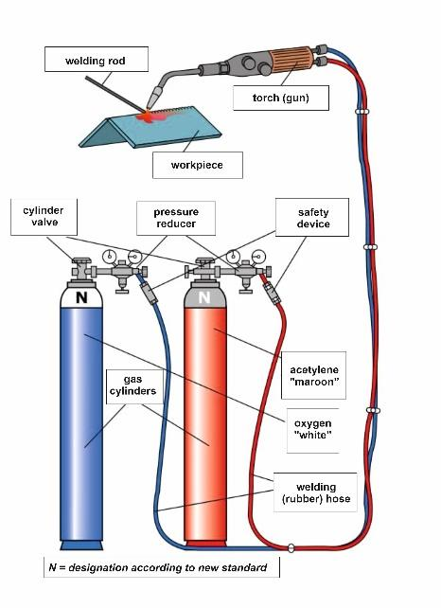
Figure 1.1. Principle of gas welding
Gas welding in today's sense only became known in 1903, when the Frenchman Edmond Fouchè developed and patented the first gas welding gun with an injector working with acetylene-oxygen.
Acetylene was first produced by the German Friedrich Wöhler in 1862.
The first technical book dealing with gas welding was written by the engineer Theodor Kautny, which was published in Halle in 1909 under the title "Handbook of autogenous welding".

1.2. Welding gases
Welding gas is any gas that is used for bulk welding of metals to form the joint. The welding gas can be flammable or non-combustible gas.

1.2.1. Combustible gases
Combustible gases burn in the presence of oxygen and provide the heat required for welding.
Combustible gas | Density*,  ρ  kg/m³ | Heating value  kJ/m³ | Maximum flame temperature with oxygen,  ºC | Ignition temperature in air,  ºC | Explosive limit in air  % | Burning speed in oxygen,  m/s | Primary Flame Power,  kW/cm²
Acetylene  (C₂H₂) | 1,17 | 57800 | 3180 | 335 | 3−82 | 13,5 | 44,8
Hidrogen  (H₂) | 0,09 | 10800 | 2525 | 585 | 4,0−75 | 8,9 | 14,9
Propane  (C₃H₈) | 1,83 | 93000 | 2850 | 510 | 2,1−9,5 | 3,7 | 10,4
Methane  (CH₄) | 0,67 | 36000 | 2770 | 645 | 4,0−17 | 3,3 | 13
*air density ρ= 1.21 kg/m³
Table 1.1. Main characteristics of combustible gases used in gas welding

1.2.1.1. Acetylene
Acetylene is a colorless, non-toxic, combustible, unsaturated hydrocarbon gas with a characteristic odor due to its impurities, lighter than air (ρ = 1.17 kg/m³). Its structural formula is C₂H₂.
The gas pressure during use must not exceed 0.15 MPa (1.5 bar). The acetylene-air gas mixture is explosive between 3-82%, the acetylene-oxygen gas mixture between 2.5-93%.
The acetylene-oxygen gas mixture set at neutral flame gives the flame with the highest flame temperature (3180ºC), the highest burning speed (13.5 m/s in oxygen) and flame power (44.8 kW/cm²).
The flame power is the amount of heat transferred to a unit surface (e.g. 1 cm²) in a unit of time (e.g. in 1 s), in kW/cm² (1 kW/cm² = 1 kJ/ cm²·s).
1.2.2. Oxygen
Oxygen is colorless, odorless and tasteless, slightly heavier than air (ρ=1.43 kg/m³), highly reactive non-combustible gas that fuels combustion.

1.3. Gas supply to workplaces

1.3.1. Central gas supply
In the case of a central gas supply, the gas is sent from the central gas storage unit to a pipeline network at a reduced pressure through the unloading stations, the pressure of which can be further reduced at the various places of use, or can be connected to the equipment. It is also advisable to establish a central gas supply if the gas is used in one place, but due to the high gas consumption, gas must be bought from several bottles at the same time.

1.3.2. Bottle plant, bottle stack
It is advisable to build a bottling plant in a workshop with several employees. In such a case, the hourly gas consumption may exceed the value allowed for an individual bottle. In the case of larger local gas demand or the operation of a central gas distribution network, instead of individual gas cylinders, it is advisable to use units consisting of several cylinders connected in parallel, called cylinder bundles. In this case, individual bottles without separate shut-off valves are connected in series with a permanent line so that the gas charge can be emptied from all the bottles at the same time with a central withdrawal (and also filling) valve.

1.3.3. Individual gas cylinder
The gas cylinder is a cylindrical pressure vessel made of metal with a deep convex bottom and a neck-shaped top, equipped with a shut-off valve, which is used to store and transport compressed, liquified or dissolved gas under pressure. The modern bottles used for compressed industrial gases and gas mixtures, as well as carbon dioxide, are made of high-quality, usually chromium-molybdenum alloy steel, or special aluminum alloys (e.g. refined Al-Mg-Si) in a seamless design. The bottles containing each type of gas are provided with a unique color code to distinguish the gas bottles, or in order to detect the gas stored in them. The color marking must be placed on the shoulder of the bottle. The bottle of industrial oxygen is white. In the case of acetylene, the bottle containing the traditional, D3 porosity filling compound is chestnut brown, the color of the acetylene cylinder containing the high porosity compound is yellow, and the shoulder is chestnut brown.
The general rule of thumb for color marking takes into account the primary hazard factor (toxic, corrosive, flammable, oxidizing, neutral). Gas cylinders must be marked with the international standard three-part marking system:
- from manufacturer and operational stamps (by stamping with a carbide tool,
by engraving, casting or other similar method),
- determination of the gas cylinder and its contents from hazard identification labels
to facilitate, to warn of the most important dangers,
- from color marking to identify the filling of the bottle if the label cannot be read.
In addition to the above, the following stamped data can be found on the shoulder of the bottle:
- maximum filling pressure (bar),
- name of owner,
- pressure test expert (boiler safe) mark,
- production (first use) date (year/month),
- strength characteristic (N/mm2),
- heat treatment identification mark,
- geometric capacity (litres),
- production number,
- manufacturer's mark.

1.3.3.1. Storage of acetylene in a gas cylinder
The acetylene required for welding is filled in 10, 14, 20, 27, 40 and 50 liter bottles, it is possible to order based on the weight of the filling. The acetylene cylinder is filled with a porous material (mass). Liquid acetone (dimethylketone) or dimethylformamide is poured into this porous mass, which absorbs the liquid like a sponge and reduces the risk of explosion above an overpressure of 0.15 MPa. Acetylene dissolved in acetone and absorbed in a porous mass is called disugas. Due to the pore structure of the traditional, so-called D3 type, heterogeneous filler mass (charcoal, asbestos, diatomaceous earth, cement), the porosity of around 75% is formed after the drying process.

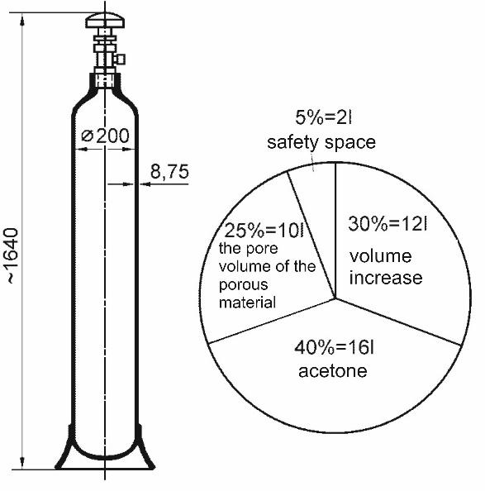
Figure 1.3. Structure and volume ratio of the acetylene cylinder

The gas can be removed from the bottle through a bottle valve with a conical thread that can be folded into the bottle shoulder. In the case of industrial gases, the material of the bottle body is usually brass, and the material of the sealing rings is Teflon or synthetic rubber of a quality that, based on its combustion technical properties, is also safe in high-pressure oxygen. The valve of the acetylene cylinder can only be made of brass with a copper content of less than 70% (an alloy of copper and zinc), since acetylene forms an explosive copper-acetate compound with copper, but the material of the valve can also be steel. With the exception of acetylene, the threaded connections are left-handed in the case of combustible gases, and right-handed in the case of neutral and oxidizing gases.

1.3.3.2. Storage of oxygen in a gas cylinder
Oxygen used for industrial purposes 10, 14; 27; 40; and filled in 50 liter bottles. The filling pressure in the 40 liter is 15 MPa (150 bar), in the 50 liter it is 20 MPa (200 bar). According to this, the full bottle contains 6,000 l (6 m³), or 10000 l (10 m³), gas is compressed.

1.4. Gas welding equipment
The gas welding equipment consists of the gas welding device (gas cylinder, pressure reducer, welding gun, safety devices, etc.) and the gas pipeline (hoses and pipelines).

1.4.1. Pressure reducer

The job of the welder is a pressure reducer (reducer) in the bottle, or reducing the higher (input) pressure in the pipeline to the operating (output) pressure, maintaining it at a constant value even in the case of variable gas intake, guaranteeing continuous gas intake, protecting the bottle from flame backlash or pressure backlash. On the cylinder valve, the acetylene pressure reducer is fitted with a stirrup, the oxygen pressure reducer is fitted with a right-hand, ¾” (21.8 mm diameter, 14 threads/1” pitch) Whitworth thread nut, the hydrogen and all other combustible gases (except acetylene) are left-handed, with the previous it is fixed with a nut of the same diameter and thread pitch. The pressure reducer can be single-stage or two-stage.

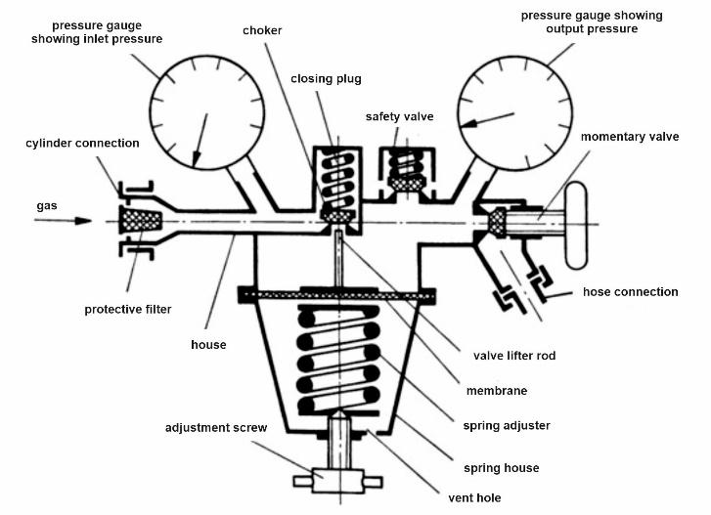

Figure 1.4. Single-stage welding pressure reducer

The pressure reducer is actually a valve with diaphragm control. After opening the valve of the gas cylinder, the gas flows into the high-pressure (inlet pressure) space of the pressure reducer, while there is no gas outflow when the adjusting spring is de-energized (unscrewed). The inlet pressure gauge then shows the pressure of the gas in the bottle. In the case of gas intake, the pressure of the desired output (operating) gas must first be set with the adjusting screw. Then the spring lifts the elastic membrane - through it the shut-off valve and the gas flows into the low-pressure space, and when the discharge valve (momentary valve) is opened, the gas enters the hose or gets into a pistol.
The pressure reducer housing or spring cover must be marked with the following:
- the manufacturer, or name or mark of the distribution company,
- classification in the pressure reducing class,
- type of applicable gas (or its short sign),
- the value of the highest inlet pressure.

The two-stage pressure reducer has two pressure regulators built into one in a common housing. One of the pressure reducers is connected to the gas cylinder and is adjusted to a pressure reduced to a given value (e.g. 15 bar pressure for an oxygen cylinder). The other pressure reducer reduces this pressure to the value required for welding (or cutting). In this way, the operating pressure can be kept at a constant value for a long time, and the pressure can be more finely regulated.
The order of installation of the pressure reducer on the gas cylinder is as follows:
- removing the protective cap of the gas cylinder, checking that the valve is closed, then removing the scum,
- blowing out the gas bottle valve by carefully opening it by ¼ turn, (located on the side of the spout),
- checking the connection nut and sealing ring (dry fiber ring can be used, leather, oily car, etc. cannot),
- check that the adjusting screw is untwisted, the momentary valve is closed,
- the hollanderer screw, or connecting the stirrup clamp to the gas cylinder,
- connection of the flame arrester to the pressure reducer, the rubber hose and installation of the welding gun,
- carefully opening the valves of the bottles, on the inlet pressure manometer a cylinder pressure, as well as checking the tightness of the connections.

1.4.2. Rubber hoses and hose connectors
The rubber hose is made with a cross-woven synthetic textile braid taking into account the stress and durability. The oxygen hose is three-line, the acetylene hose is two-line.

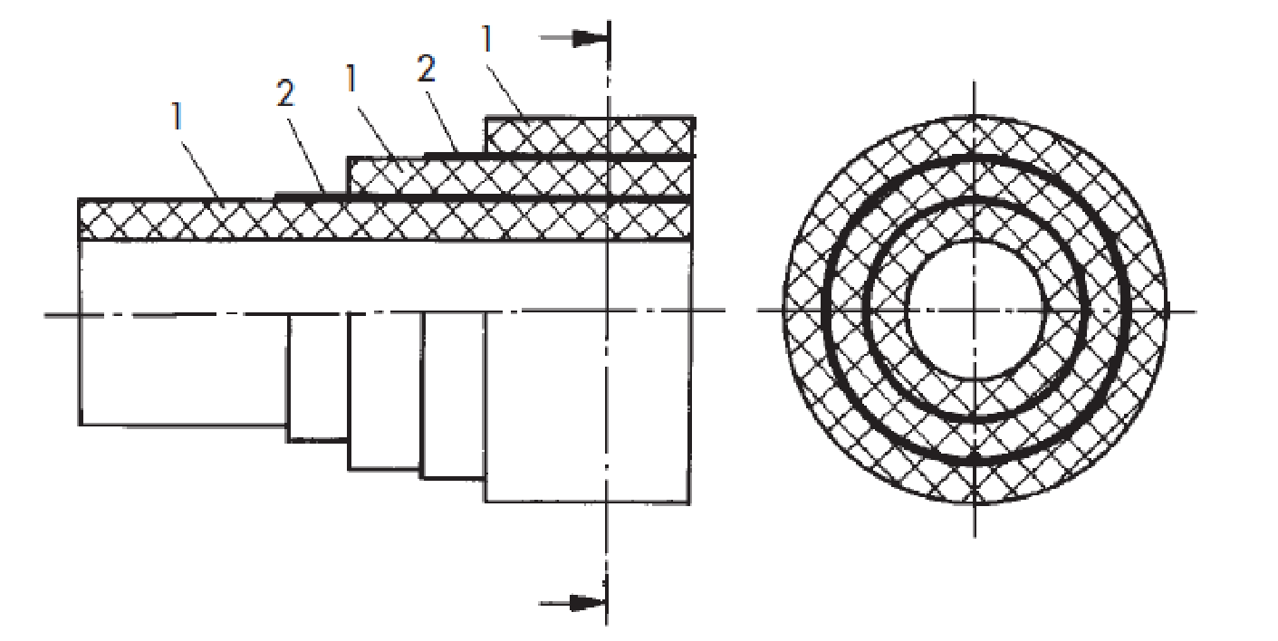
Figure 1.5. The structure of the rubber hose
1: rubber hose; 2: linen insert
Ø 11 x 4 mm Ø 11 x 4 mm rubber hoses of up to 10 m length are used for oxygen and Ø 14 x 6.3 mm rubber hoses for acetylene. The usual nominal (internal) diameters are: 4.0; 5.0; 6.3; 8.0; 10 mm. The color marking of the oxygen hose is blue, that of the acetylene hose is red.
The following must be permanently and clearly marked on the outer surface of the hose every 1 meter:
- the reference to the European standard,
- the maximum operating pressure in MPa and in brackets in bar,
- the nominal (inner) diameter of the hose in mm,
- brand name of the manufacturer and supplier,
- date of manufacture.

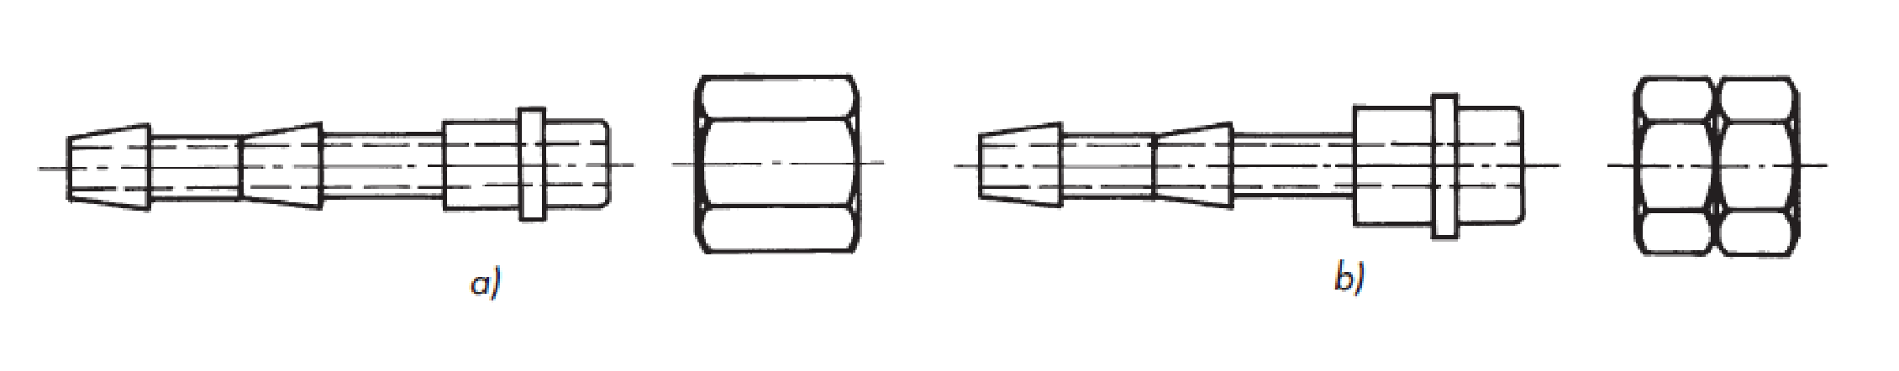
Figure 1.6. One-sided hose connector and hollander nut
a) for oxygen; b) to acetylene

The rubber hose must only be connected to the gun with a standard hose connector. Its material can be brass (a copper-zinc alloy) containing a maximum of 70% copper.

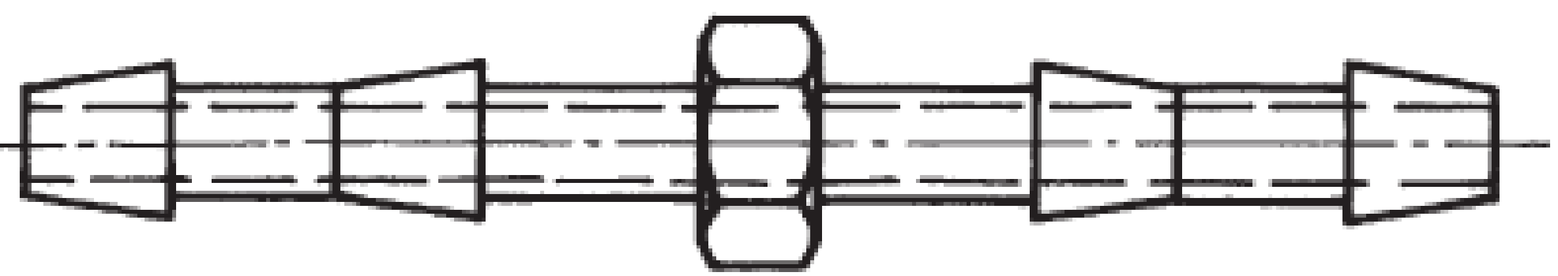
a
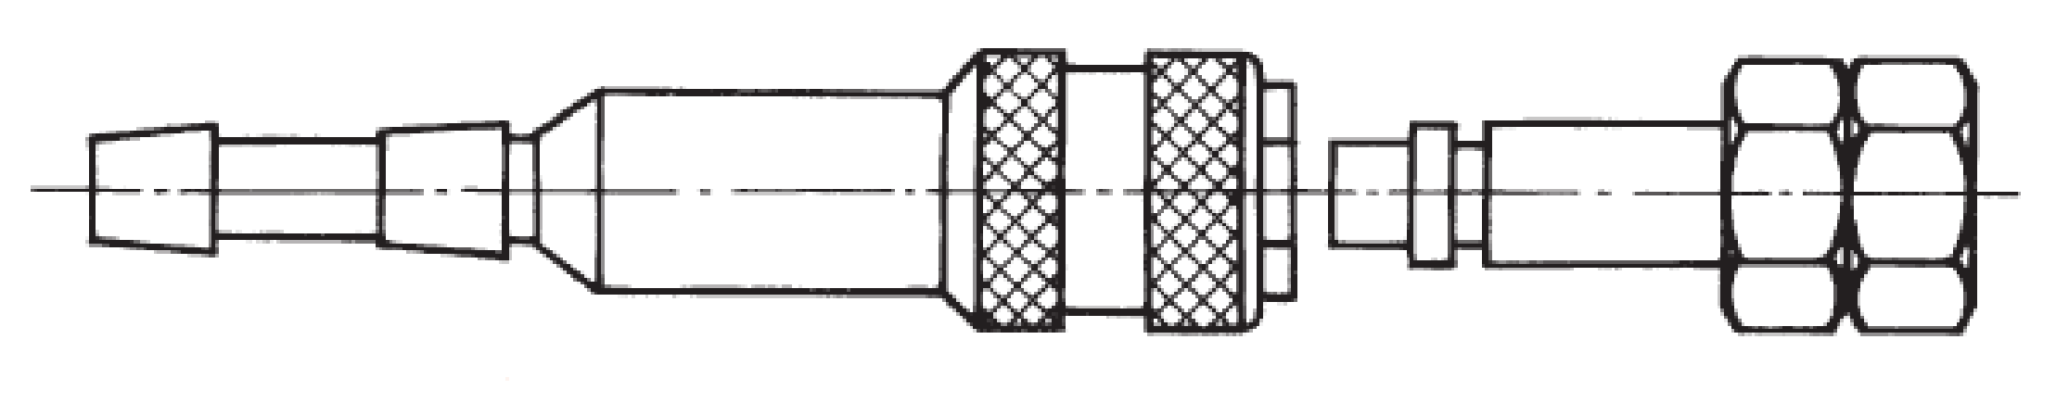
b
Figure 1.7. Connecting extensions
a) double extension, b) self-closing connection extension
For connecting the hoses, e.g. when extending or repairing the hose, a double hose connector extension or a double threaded connector must be used. The connector end must match the size of the hose. The hose can be reliably attached to the connection end with a hose clamp, it is forbidden to fasten it with wire or any other means!

1.4.3. Low-pressure injector welding gun
The task of the welding gun is to mix the combustible gas and oxygen, and to lead the gas mixture into the burner head.
Acetylene must be introduced into the low-pressure (suction or injector) welding gun by the suction effect of higher-pressure oxygen, if the gas pressure is not enough to get enough gas into the gun. At the nozzle opening, the gas outflow velocity must be greater than the combustion velocity, otherwise the combustion will propagate backward into the gun. To avoid this, an injector welding gun is used. The parts of the welding gun are the handle, the mixing shaft and the burner head. The gas control valves are located on the handle, which can be used to adjust the quantity and mixing ratio of the gases. Oxygen and acetylene are connected to the handle with a detachable hose connector.

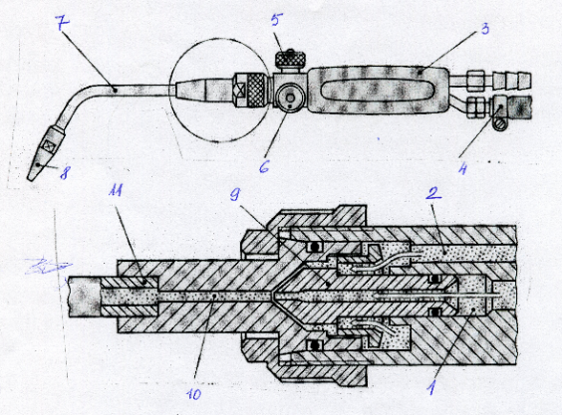

Figure 1.8. Low-pressure injector welding gun
1: oxygen; 2: acetylene; 3: handle; 4: connecting clamp; 5: oxygen valve; 6: acetylene valve;
7: stem tube; 8: burner head; 9: pressure nozzle, 10: mixing nozzle; 11: conical mixing tube

In the injector mixing stem, the combustible gas and oxygen are mixed in such a way that the higher pressure oxygen flows through the injector mixing nozzle, creates a pressure drop in the conical mixing tube and sucks in the combustible gas. A pipe section with a decreasing cross-section in the direction of flow is called a confusor, and an expanding pipe section is called a diffuser. In the confusor part of the gun, the higher pressure (0.18...0.25 MPa overpressure) oxygen accelerates and takes the lower pressure (0.03-0.08 MPa overpressure) acetylene with it. The gases mix in the diffuser and their speed slows down. With a neutral flame, the outflow speed is 110−130 m/s, while the burning speed with an acetylene-oxygen gas mixture is 13.5 m/s. The gas outflow rate can be adjusted by changing the stirrer stem without changing the acetylene-to-oxygen ratio. If the flow rate of the gases from the burner head is too high (too much acetylene and oxygen), the flame will "fly away", and if it is too high, the flame may return to the stirrer (backburn). The mixing rod is made of copper to conduct heat well, to cool down quickly, and not to heat up the gas mixture flowing in it to the ignition temperature (335ºC in the case of an acetylene-air mixture). The mixing stem can be made of red copper because it does not flow with acetylene, but with an acetylene-oxygen gas mixture.

Interchangeable mixing rods are manufactured in different sizes and numbered (1−8).
If the hole of the stirrer stem is clogged, it must be cleaned with a soft needle with a diameter corresponding to the hole (0.5...2.4 mm), because the contamination makes the flame core irregular, making it difficult to adjust the flame accurately.

1.4.4. Safety devices

Improper use or improper maintenance of the welding gun can cause the flame to travel back from the gun to the cylinder, causing the pressure reducer or pressure gauge to burn, the rubber hose to crack, the gun to be damaged, or the gas cylinder to explode.
Malfunctions that often occur when using gas welding devices, their recognition, cause and options for elimination are described in Table 1.4. summarizes.

Malfunction
appearance | recognition | reason | termination
Cut back | Explosive (rapid) combustion of the gas mixture accompanied by a roaring sound | Excessive heating or loosening of the mixing rod | Both valves on the gun must be closed and the gun must be cooled in water.
Backburn | The flame suddenly retracts into the burner and burns inside with a whistling sound. | The outflow velocity of the gas mixture is less than its combustion velocity | The amount of gas mixture must be increased, which results in an increase in the outflow velocity
Backfire | The backfire spreads to the injector and flows into the lower pressure gas line. The situation is accompanied by an explosive sound and heavy sooting. | Sudden decrease in the outflow velocity of the gas mixture, especially with larger mixing rods | Both cylinder valves must be closed immediately. The pressure reducer on the acetylene cylinder must be removed and the cylinder inspected.
Backflow | The higher pressure gas of the gas mixture flows into the lower pressure gas line | Contaminated burner, which partially or completely blocks the burner hole, faulty seal | Cleaning the burner head with the reamer provided for this purpose, checking the seal
Table 1.4. Welding safety devices

Since malfunctions according to the table cannot be completely excluded, welding equipment must be equipped with appropriate safety devices according to the Welding Safety Regulations (HBSz). Separate regulations also apply to the bundle of bottles, bottle farm and individual bottles. The acetylene cylinder stack, or each gas sampling location of a bottling plant must be equipped with a safety device that prevents
- the return of the flame from the burner to the gas line,
- the return of oxygen to the acetylene line,
- the afterflow of acetylene during flashback.
The flame arrestor is a shrunk, porous metal filter (sinter metal), which prevents the flame from spreading in the line section behind its location (Figure 1.9).

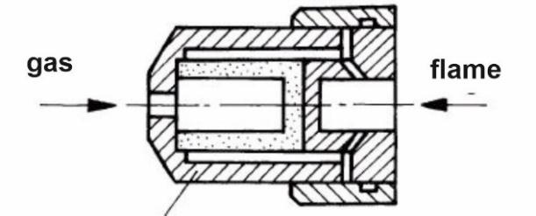
Figure 1.9. Flame arrester
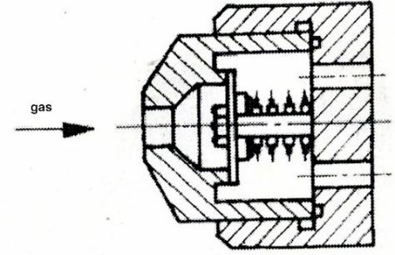
Figure 1.10. Non-return valve
The non-return valve is a spring-loaded diaphragm valve that prevents sudden gas backflow. (Figure 1.10). The valve is kept open by the gas flow. The valve closes if a flow in the opposite direction to the gas flow occurs. A common safety device in autogen technology is the anti-flame backlash cartridge, in which the flame arrester and the non-return valve are integrated into one. The cartridge shown in the Figure 1.11. also contains a heat-sensing shut-off valve.
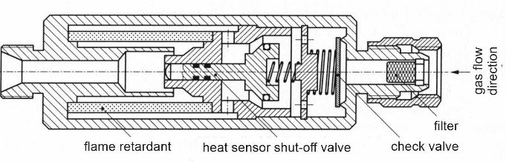
Figure 1.11. Anti-flame backlash cartridge
Individual cylinder protection is required if only one welding gun is operated from the acetylene cylinder. The anti-flame backlash cartridge can be installed on the pistol grip, in the acetylene hose, or before the pressure reducer in according to Figure 1.12.

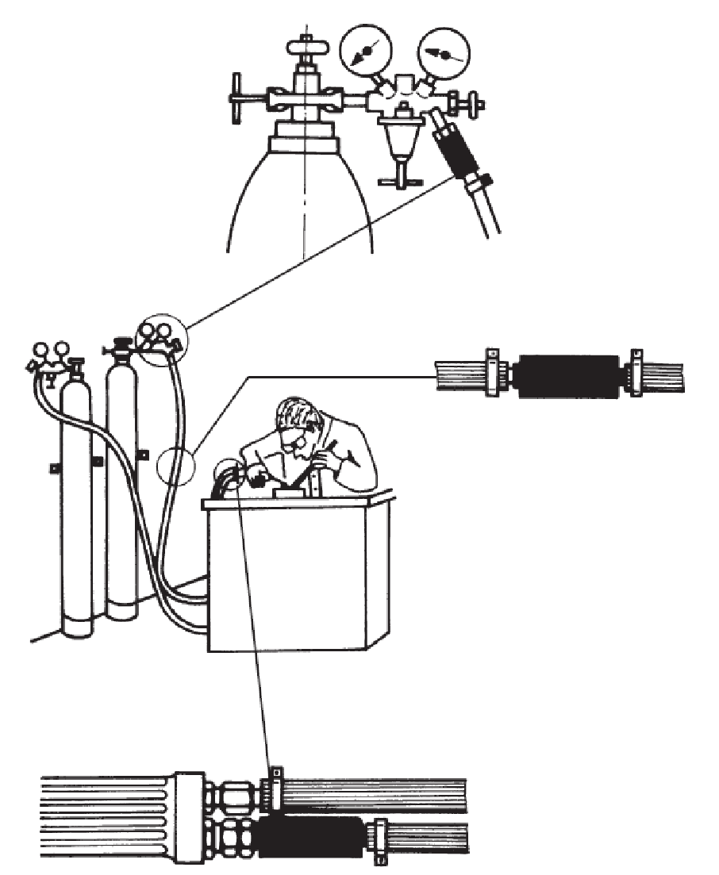
Figure 1.12. Individual bottle protection versions
Repeating and checking questions
1. What are the main characteristics of gas welding?
2. What is dissous gas?
3. Describe acetylene!
4. What is the difference between acetylene gas and disugas?
5. What does a dissous gas bottle contain and in what percentage?
6. How can the amount of gas in an acetylene cylinder be determined?
7. What is the role of the welding pressure reducer?
8. How does the single-stage pressure reducer work?
8. What is the role of the welding gun?
9. What do you mean by injector principle?
10. What are the main parts of a welding gun?
11. What is called a security device?
12. What is the role of the flame arrester?
13. How does a flashback cartridge work?
14. What is called unique bottle protection?

2. The process of gas welding

2.1. Commissioning of the welding equipment
The sequence of putting the assembled injector welding gun into operation is as follows:
- checking the loose state of the regulating screw on the pressure reducers,
- carefully opening the cylinder valves by ½ turn,
- setting the operating pressure for both cylinders is the adjusting screw clockwise by turning it in the appropriate direction until the pressure on the manometer does not show the desired value,
- flushing the rubber hoses through the oxygen valve on the pistol grip, then it by turning the acetylene valve (about ¼ turn),
- ignite the flame with a spark igniter, making sure that the gun is in a safe direction
- -adjust the flame with the valves on the handle depending on the application.

2.2. Welding flame
The structure of the acetylene-oxygen flame is shown in Figure 1.13. The chemical nature of the flame and the flame temperature are affected by the acetylene: oxygen ratio.

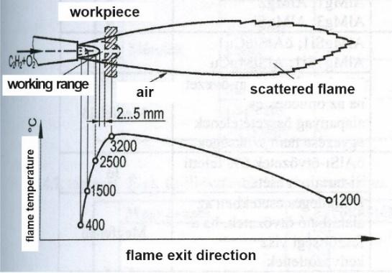
Figure 1.13. The neutral welding flame and its structure
The acetylene-oxygen ratio is 1:1-1:1.1

In the case of an acetylene-oxygen flame, the flame can be neutral, reducing or oxidizing (Figure 1.14). The flame is neutral if the ratio of the two gases is approx. 1:1. The flame then consists of three distinct parts, the flame core, the butterfly and the broom. The flame core is the part of the welding flame that has a bluish glow and is bounded by a sharply defined conical surface. In the flame cone jacket exiting the burner head at high speed, acetylene breaks down into its components, i.e. carbon (C) and hydrogen (H₂). In the butterfly, carbon and oxygen combine to form carbon monoxide. As a result of imperfect combustion (2C+2H₂+2O₂→4CO+2H₂), this zone has a reducing effect. The elements to be welded should be 2-5 mm from the end of the flame core, then the CO+H₂ gas mixture sufficiently protects the melt from the harmful effects of oxygen in the air, and here the flame temperature will be the highest (≈3200ºC). The flame temperature decreases if the combustible gas: oxygen ratio differs from 1:1. The perfect combustion of acetylene: oxygen takes place in the broom (scattered flame), then the two gases burn into carbon dioxide and water vapor (4CO+2H₂+3O₂=4CO₂+2H2O). Non-alloyed and low-alloyed steels and steel castings, heat-resistant steels, copper should be welded with a neutral flame.

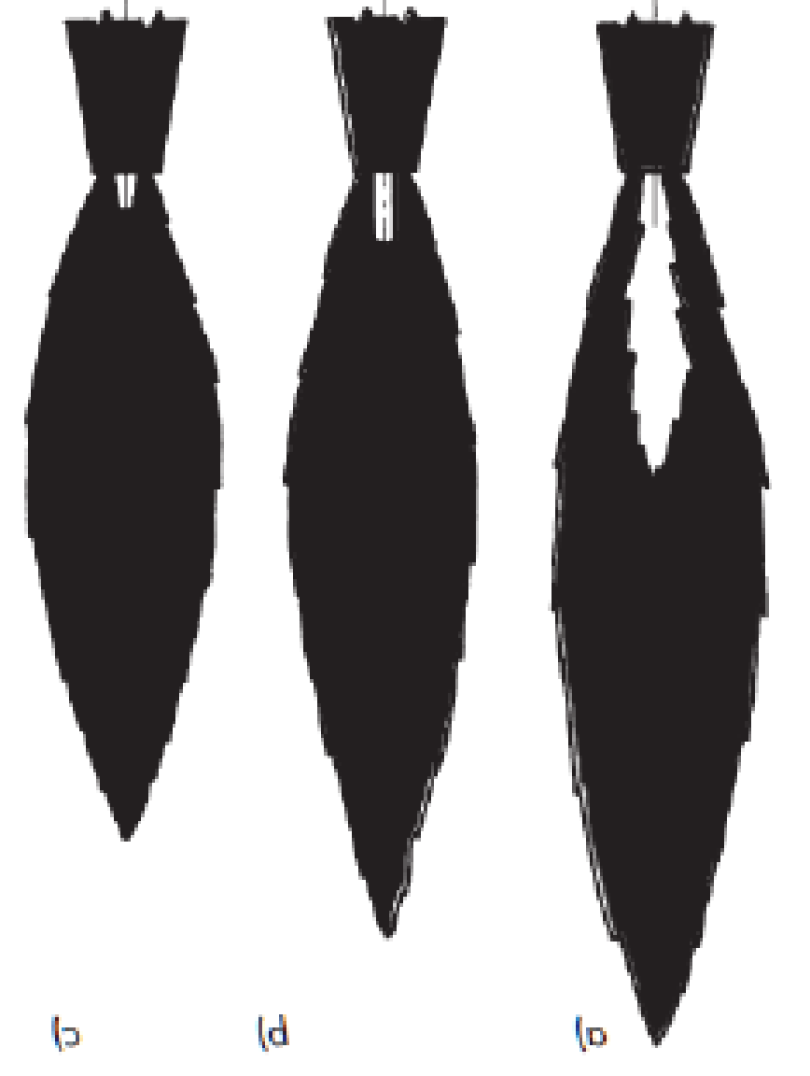
Figure 1.14. Flame types
a) reducing (acetylene-rich); b) neutral (normal); c) oxidizing (oxygen-rich)

In case of an excess of acetylene (acetylene-rich or reducing flame), the flame core disappears and a long flame with an irregular outline, flagging, yellowish-green color is created. Cast irons and tool steels with a high carbon content can be welded with such a flame. It is not recommended for welding unalloyed steels, as the carbon absorption of the melt can increase the risk of hardening.
In the case of an excess of oxygen (oxygen-rich flame), the pointed and bluish flame core with a strong hissing sound has an unfavorable effect, as it oxidizes the metal. This flame is only used when gas welding brass (copper-zinc alloy) to reduce the evaporation of zinc.

2.3. Gas welding stick
In most cases, gas welding requires filler material to fill the gap to be welded. Gas welding rods usually have a round cross-section and are manufactured in different diameters (1.6; 2.0; 2.4; 3.2; 4.0; 5.0; 6.0 mm) and 1000 mm long. It is important that the surface of the stick is metal clean. If the surface is rusty, cracked or greasy, it must be cleaned. The gloves used by the welder must also be clean, as well as the welder's hands. Sticks can only be stored in a dry room.
For a given task, it is advisable to select the rod diameter according to the thickness of the workpiece to be welded. If the rod is too thin, it will melt quickly, overheat, there will be a lot of spatter and the burnout of the alloys will be more severe. If, on the other hand, it is too thick, it is more difficult to make a high-quality binding, accessibility is reduced, and the seam bulge will be too large.
For welding mild steels to the left, the rod diameter should be dp = s/2 + 1 mm, where s is the wall thickness in mm. When welding to the right, in the case of s ≤ 5 mm, the diameter of the stick should be the same as the material thickness, for s= 6−12 mm (0.5−0.6)s. When making a multi-layer seam, a thinner stick should be used for the root, and a thicker stick for the filling and covering seams.
Steel welding rods are made of unalloyed or low-alloyed steel with a low C content (max. 0.25%)
The unalloyed or Types of welding rods recommended for welding low-alloy steels and their chemical composition can be found in Table 1.5., their thawing characteristics in Table 1.6. contains. The rods belonging to the OV and OVI rod classes are made of Cr-Mo alloy, so they are mainly recommended for welding heat-resistant steels.

Wand class | Chemical composition, %
Wand class | C | Si | Mn | P | S | Mo | Ni, Cr
OZ | minden egyéb összetétel
OI | 0,03-0,12 | 0,02-0,20 | 0,35-0,65 | ≤0,030 | ≤0,025 | - | -
OII | 0,03-0,20 | 0,05-0,25 | 0,50-1,20 | ≤0,025 | ≤0,025 | - | Ni=0,35-0,80
OIII | 0,05-0,15 | 0,05-0,25 | 0,95-1,25 | ≤0,020 | ≤0,020 | - | -
OIV | 0,08-0,15 | 0,10-0,25 | 0,80-1,20 | ≤0,020 | ≤0,020 | 0,45-0,65 | -
OV | 0,10-0,15 | 0,10-0,25 | 0,80-1,20 | ≤0,020 | ≤0,020 | 0,45-0,65 | Cr=0,80-1,20
OVI | 0,03-0,10 | 0,10-0,25 | 0,40-0,70 | ≤0,020 | ≤0,020 | 0,90-1,20 | Cr=2,00-2,20

Table 1.5. Unalloyed and low-alloyed steel welding rods

Wand class | Liquidity | Tendency to splash | Porosity tendency | Color marking
OI | thin-flowing | great | great | nothing
OII | less  fluid | less | great | grey
OIII | flowing heavily | not prone to | not prone to | gold
OIV | flowing heavily | not prone to | not prone to | red
OV | flowing heavily | not prone to | not prone to | yellow
OVI | flowing heavily | not prone to | not prone to | green
Table 1.6. Melting characteristics of steel welding rods and their color marking

Steel type | Smallest yield strength,  R_{eH,}  MPa | Tensile strength,  R_{m},  MPa | Minimum elongation at break  A₅,  % | Minimum rupture energy  at 20ºC  K,  J
S185 | 185 | 310-540 | 18 | -
S235JR | 235 | 360-510 | 26 | 27
P235GH | 235 | 360-480 | 24 | 40
P235TR1 | 235 | 360-500 | 25 | 27
S275JR | 275 | 430-580 | 23 | 27
P275NH | 275 | 390-510 | 24 | 75
16Mo3 | 275 | 440-590 | 22 | depends on order
13CrMo4-5 | 300 | 450-600 | 19 | depends on order
10CrMo9-10 | 310 | 480-610 | 18 | depends on order
Table 1.8. Mechanical characteristics of some unalloyed and low-alloyed steels recommended for gas welding

Marking example
Welding rod EN 12536 O III

Delivery status

Standard number

Welding process

Welding rod classification
2.4. Position and control of the baton and pistol

Welding can be done without a welding rod (e.g. edge seam, I seam) or with a welding rod. From the point of view of bulk welding, it is important what angle the gun and stick form with the elements to be welded in a given welding position. If the gun (and flame) points towards the unwelded base material, it is called left welding, if it points towards the melt, it is called right welding.
Figure 1.15. shows a welding operation to the left for plate welding in a horizontal position
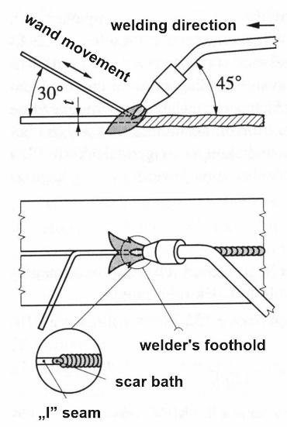
Figure 1.15. Welding plates to the left in a horizontal position

When welding steels to the left, the gun should make an angle of 45º and the stick a 30º angle to the plane of the seam. If the welder feeds the stick with a dipping motion, the gun should move forward in a straight line. Then the welder keeps the end of the stick near the flame in a preheated state, until the flame melts the raw material. Then, by moving the stick in the axial direction and placing it in front of the flame core, wait for the end of the stick to drop, then pulling it out in the axial direction for the raw material to pour. By continuously repeating these operations, the melt is formed, or the seam. When pulling the stick out of the flame, oxidation of the glowing stick end can be a problem, which can cause gas porosity in the seam. The dipping motion is usually used for steels up to a thickness of 3 mm. Over a thickness of 3 mm, the elements to be connected must be sharpened in a V shape at an angle of 50...60º. Above 3 mm, the stick and the gun make an arcing movement in opposite directions. Then the stick does not shade the flame and thus the edges can be welded together perfectly. The flame constantly bypasses the stick in front of it, and thus the heating of the lower edges will also be adequate. The drop of the wand tip occurs when the wand meets the gun. This technique is also suitable for welding material thicknesses of less than 3 mm.
Advantages of welding to the left:
- smooth or only slightly scaly seam surface,
- lower heat input,
- suitable for connecting thin wall thicknesses (below 3 mm).
Disadvantages of welding to the left:
- greater heat loss,
- slightly forward scar bath,
- greater deformation,
- proper remelting of the root cannot be detected during welding, since a
flame is directed to the raw material,
- the flame does not protect the melt from the constituents of the air, so the finished seam
can be more porous.
The field of application of welding to the left: s ≤ 4 mm thick unalloyed or low-alloyed steel, cast steel, cast iron, aluminum and its alloys, copper and its alloys.
When welding to the right, the flame is directed towards the weld pool, thereby keeping the melt warm (Figure 1.16). The flame protects the melt from the air, reduces the cooling of the melt and, in the case of hardenable steels, the risk of hardening. When welding steels to the right, the angle of the gun in relation to the plane of the seam should be 35-45º, and the stick should be 40-50º. When welding aluminum, copper and their alloys, the angle of the gun should be 45-90º and the angle of the stick 15-30º.

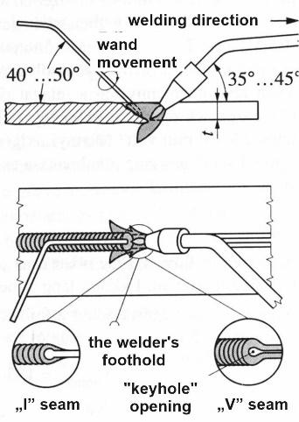
Figure 1.16. Welding plates to the right in a horizontal position
material thickness

For smaller wall thicknesses (4−5 mm) the bending angle is steeper, for thicker elements (s >8 mm) it is smaller (45º). The end of the flame core should extend into the seam trough up to a third of the material thickness, thus the edges can be poured through with greater safety. Since the flame is directed at the melt, a flame that is too strong can blow the melt apart. The loosening of the edges is shown by an opening similar to a keyhole, the maintenance of which can guarantee the creation of a root defect-free seam. The blowing effect of the flame blows part of the melt into the opening thus formed. The gun moves forward in a straight line while the wand moves in a circular motion. The stick constantly stirs the melt, which has the advantage that gases and slag can be stirred to the surface of the melt.

Advantages of welding to the right:
- lower cooling rate (reduction of exercise risk),
- less warping due to lower heat input,
- more reliable root melting due to the keyhole effect,
- the flame protects the melt better from the air,
- remelting a larger cross-section in one step.
Disadvantages of welding to the right:
- it is difficult to apply with a material thickness of 3 mm,
- rougher scaly surface.

2.5. Seam making in different positions
When butt-welding plates are made in a horizontal position (PA position), the seam production depends on the edge design and thickness of the elements to be welded. Table 1.9. shows the technological data recommended for making butt-welded joints of unalloyed steel sheets.

Sheet thicknes  s,  mm | Number of mixing rods | The seam |  | rod diameter  d_{p},  mm | Specific characteristics
Sheet thicknes  s,  mm | Number of mixing rods | type | measure  mm | rod diameter  d_{p},  mm | O₂l/h | C₂H₂l/h | Stick-  weight loss  g/m | Welding time  t_{h},  min/m | Seam length,  l,  m/h
1 | 0,5−1 | edge seam | ≈1 | - | 80 | 80 | - | 9 | 6,7
1,5 | 1−2 | edge seam | - | - | 160 | 160 | 12 | 10 | 6
2 | 1−2 | I seam | ≈1 | 2 | 160 | 160 | 35 | 11 | 5,5
3^{x} | 2−4 | I seam | ≈2 | 2 | 315 | 315 | 65 | 12 | 5
4^{x} | 2−4 | V seam | 2-4 | 3 | 315 | 315 | 115 | 15 | 4
6^{x} | 4−6 | V seam | 2-4 | 4 | 500 | 500 | 250 | 22 | 2,7
^{x}welding to the right
Table 1.9. Technological data for butt welding of unalloyed steel sheets

A horizontal edge seam up to 3 mm thick can be made without a stick or with a stick. Since radical fusion does not need to be taken care of, the process can be carried out easily and faster, which reduces the warping of the elements.

Plates can be joined perpendicularly with butt welds or corner welds, PA (trough) or In PB position. When butt welding, it is advisable to sharpen one of the elements (on one or both sides) for better weldability. The seams of steel plates must be welded to the left up to 4 mm, and to the right above.
When joining with a fillet weld, the PA trough position is more favorable than the PB position. The external corner seam of thin plates can be made without a stick, if one of the plates protrudes by 1-2 mm and then this must be melted into the melt. In this case, the raw material must be cooled vigorously in order to reduce elongation. When welding the internal fillet weld of steels, the specific flame strength should be 125 l/(mm·h) when welding to the left, and 150 l/(mm·h) when welding to the right. Making the external corner seam requires a lower flame strength (Figure 1.17).
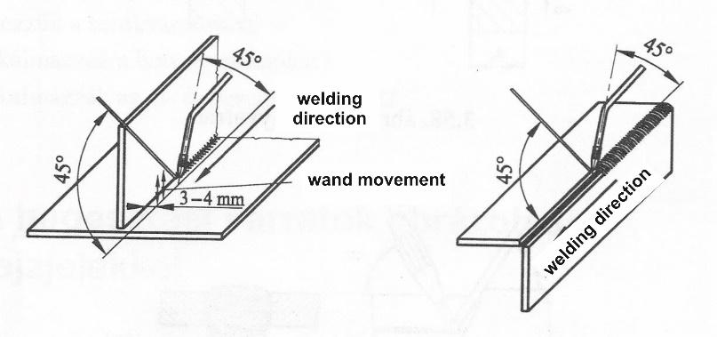
Figure 1.17 Making internal and external corner seams

Figure 1.18 shows the butt seam of plates in transverse position (PC). It is very difficult to make a seam in this position, as the melt can easily flow off due to gravity and the blowing effect of the flame. This can be avoided by keeping the gun at the right angle and the stick by moving it according to Figure 1.18. The angle of the gun with the bottom plate should be 70º.
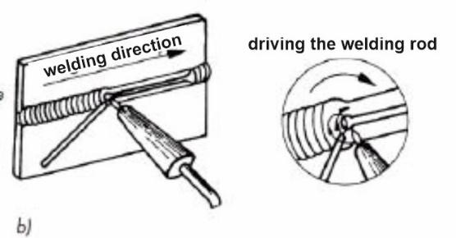

Figure 1.18. Welding of plates in transverse position
Making blunt bandages overhead (PE) is tiring and uncomfortable rather than a difficult task. The plates must be welded up to 3 mm to the left and above to the right. Figure 1.19 shows a welding to the right.

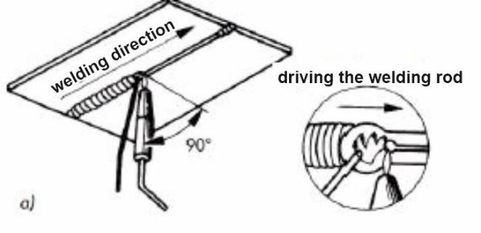
Figure 1.19. Overhead welding of plates

The gun must be held in such a way that the pressure of the flame prevents the melt from dripping, therefore it is recommended to hold a minimum amount of melt. Body parts (head, shoulders) must be protected against dripping. If a suture with a larger cross-section is to be made, it is advisable to plan a multi-layered suture, avoiding the collapse of the larger scar bath. The angle of the pistol with the plate is almost 90º, that of the stick is 45º. The guidance of the stick is shown in the enlarged part of the figure. From time to time, the stick has to be moved all the way to the base opening, because then the spilled material parts are pushed to the other side by the flame, thus forming a slightly convex seam there. The working time of overhead welding is approx. It is 40...50% longer, and the gas consumption is 15...20% lower than when welding a sheet of similar thickness in a horizontal position.

Figure 1.20 shows the process of butt-welding (PF) jointing of plates on a vertical wall from bottom to top. fig. The vertical position facilitates the melting drops to reach the scar bath, the keyhole opening characteristic of welding appears to the right, so that the correct design of the root can be continuously checked.

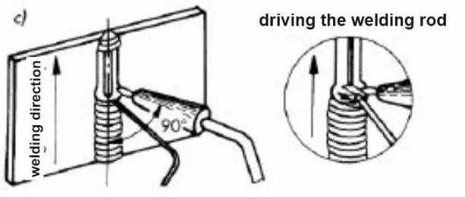
Figure 1.20. Welding plates vertically from bottom to top
When butt-joining a rotated pipe with a horizontal axis, one quarter of the pipe diameter must be made in a horizontal position (PA), and then the pipe seam must be made by turning it into this position. At the start, the uniaxiality of the two pipes must be checked. In the case of different thicknesses, if possible, the pipe end with a thicker wall must be cut down to the thinner size (s) in a length of 2s. For the purpose of more reliable root fusion, even the ends of the thin-walled pipes to be welded must be sharpened in a V shape so that the process can be better observed. On pipes with a small diameter, the flame also heats the other side of the pipe, so a lower flame intensity must be set than when welding plates of the same thickness. Root flow narrows the cross-section, which can cause flow loss in the pipeline and worsen the operating conditions.
When butt-joining a non-rotated pipe with a horizontal axis, horizontal, vertical and overhead positions can be found within a circular seam (Figure 1.21). When stringing the pipes, care must be taken to ensure that the pipes remain uniaxial. The pipes must be connected in three places, at 120º from each other. The welding must be started at the vertical tangent of the pipe and made by welding to the right in 1/8 of the pipe's circumference (according to arrow 1). After that, the pipe must be turned back by 45º (according to the 2 arrows) and the operation continued. Thus, the circular seam is completed in eight parts.

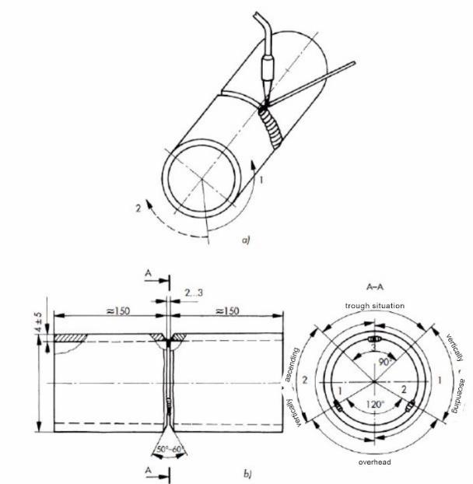
Figure 1.21. Welding positions and welding sequence when welding non-rotated pipes
a) welding sequence on the spatial image of the pipe; b) the preparation of the pipes and the situations that occur
Welding using a mirror is necessary when the welding operation cannot be observed directly. Its application requires a great deal of practice, as all displacements appear in the opposite way in the mirror (Figure 1.22). The mirror should be positioned so that the field of vision is large. The welder must work concentrating on the mirror, nothing can distract him from the mirror.

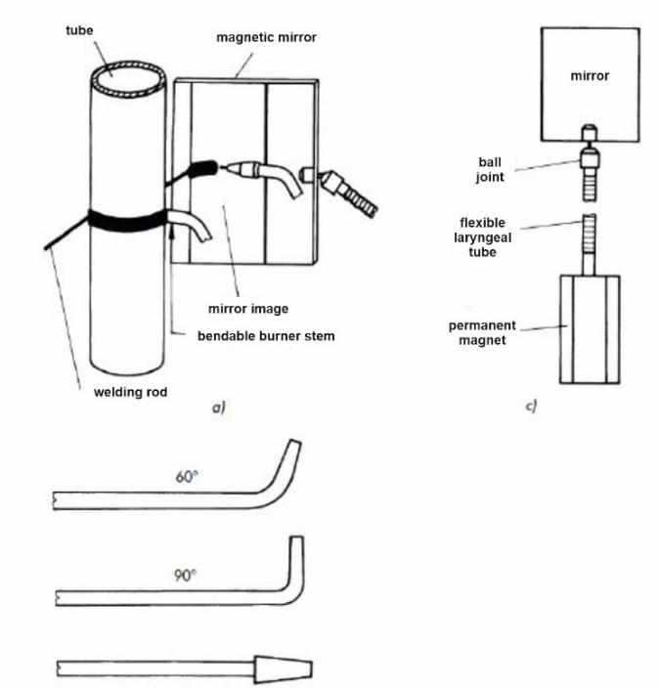

Figure 1.22. Welding using a mirror
a) arrangement of welding; b) bendable burner stems; c) magnetic mirror

Window welding is used when the distance between the pipe and the wall is too small to be able to perform the welding using a mirror. In such a case, an opening (window) must be cut on the pipe, so that the inaccessible seam can be made from the inside.

2.6. Decommissioning the welding equipment

At the end of a given welding job, the welding device must be put out of service. In doing so
1. The acetylene and oxygen valves of the gun must be closed.
2. The valves of the gas cylinders must be closed.
3. By opening the oxygen and acetylene valves, the hoses must be relieved and a
pressure reducers.
4. The adjusting screws of both pressure reducers, the diaphragms, must be loosened
and for the purpose of relieving the load on the control springs.
5. The momentary valve of the pressure reducers and the gun's oxygen and
acetylene valve.

Repeating and checking questions
- Describe the procedure for commissioning gas welding devices.
- What parts does an acetylene-oxygen flame consist of?
- What combustion processes take place in a welding flame?
- Describe the types of welding flame and their application.
- What elements does the non-alloy according to the international standard contain, or weakly alloy steel welding rod?
- Explain with a diagram the left used in different positions for steels welding!
- What are the advantages of welding to the left, or disadvantages?
- With a diagram, explain the right used in different situations for steels welding!
- What are the advantages of welding to the right, or disadvantages?
- Use diagrams to demonstrate at least the holding and driving of the baton and pistol 3 different positions!

3. GAS WELDING OF METALS

3.1. Welding of steels
Unalloyed mild steels with a low C content can be easily and well welded. The weldability of mild steel deteriorates if the steel is poorly deoxidized, contaminated with non-metallic inclusions, contains a large amount of dissolved gases and polluting elements, e.g. phosphorus and sulfur. In the case of a neutral flame, a Si content of more than 0.2% interferes with gas welding, because the silicon can cause spattering during melting.
Under normal welding conditions, preheating is not required if the elements present in the steel do not exceed the following values: C 0.2-0.25%, Mn 0.8%, Cr 0.2%, Mo 0.2 %, Ni 1-3 %. If the C content is greater than 0.25%, it is advisable to apply preheating even under normal welding conditions, in order to reduce heat dissipation and cooling (hardness).
Higher carbon content, or there may be a risk of hardening when welding alloyed steels. Welding is only reliable if the hardening of the seam and its surroundings is not significant. If the degree of hardening reaches 350 Vickers hardness, the risk of cracking increases. The increase in hardness is usually the result of rapid cooling, it is advisable to use preheating to reduce it.

3.2. Cast iron welding
Cast iron is brittle, has low elongation, and cannot be shaped. Even uneven heating can cause cracks and breaks in the structure of cast iron. The toughness and shape-changing ability of cast iron is only approx. At temperatures above 600ºC, it will be large enough to withstand the deformation associated with continuous welding. Therefore, by preheating the casting to 600-700 ºC during gas welding, the so-called welded with a hot process.
The composition of the filler material is close to that of the base material, so the strength properties of the bond are also similar. The welding rod used for welding gray iron and malleable cast iron can have a composition similar to that of the cast iron, with 3−4% C and 2.5−3.5% Si content. Their surface should be rust- and sand-free, metal-clean, their fracture should be even-grained, and free of slag inclusions. General dimensions of the stick: at Ø 4−5 mm approx. 600 mm long, for Ø 6−16 mm approx. 800 mm long. A solvent must be used to dissolve the surface oxide layer. To dissolve the oxides and transfer them to the slag, caustic soda (to transfer the acidic silicon dioxide to the slag), acidic borax and boric acid (to bind the basic oxides) are best.

Due to the high brittleness of the casting, the rate of heating up to the preheating temperature can be no more than 100ºC/h, after the welding is completed, an equalizing temperature of 0.5-1 hour is required. The cooling rate must not exceed 100ºC/h. Given that the bath solidifies slowly, guards are often used to prevent leakage.

3.3. Welding of aluminum and its alloys
When gas welding unalloyed aluminum, it must be taken into account that
When welding aluminum, the following must be taken into account:
- the welding process does not cause discoloration,
- in its swollen state, it greedily swallows hydrogen (carbon monoxide in the flame core
hydrogen is present), which leads to the porosity of the scar material,
- the pre-shaped workpiece softens due to the heat, the grains may become coarser with a given shape,
- a solvent must be used to dissolve the oxide.
Unalloyed aluminum can be welded well. Before welding, the surface must be cleaned and the oxide layer thinned by acid or alkaline pickling. After pickling, it must be washed, then neutralized with 15-20% nitric acid and finally washed again. Welding is performed with a neutral acetylene-oxygen flame, but a gas-rich flame is also permissible.

3.4. Welding of copper and its alloys
Red copper can be oxide-free, oxide-containing (< 0.1%) or deoxidized with phosphorus. The latter two can be welded well with both bulk and press welding processes. When gas welding, it must be taken into account that
- the strength of red copper in the annealed state is low (Rm=210-240 MPa), its elongation
high (40-48%),
- in the case of oxide-containing copper, when hydrogen is absorbed (Cu2O + H₂= 2Cu + H₂0) the so-called hydrogen sickness can develop, which is high-pressure water vapor inclusions
means the formation of
- copper has a lower melting point with oxygen than copper (1083ºC), the so-called eutectic
forms, it precipitates when it cools down and can reduce the toughness of copper,
- for steel approx. due to its eight times higher thermal conductivity when welding
a significantly higher heat input is required.
It is recommended to use a CuAg1 rod with phosphorus (0.02−0.05%) and silver (0.8−1.2%) content for its welding. Fluid is always necessary!
The thermal conductivity of copper alloys is much lower than that of unalloyed copper (half or even less, depending on the alloy), and since the alloys have a deoxidizing effect, they can be welded better.
Because of the zinc alloy, brass (Cu+Zn alloy) must be welded with an oxygen-rich flame. Flux is required! Hot hammering improves the mechanical properties of the seam. The appearance of porosity in the seam can always be traced back to insufficient oxygen. Recommended filler material: copper alloy with 40% Zn content (CuZn 40).

4. QUALITY OF BULK WELDING OF METALS REQUIREMENTS

4.1. Quality requirements of gas welding
In the case of some dangerous structures (e.g. pressure equipment, industrial pipelines, vehicle structures, etc.), it is particularly important to comply with the quality requirements. For this, the company producing the product must obtain a certificate of suitability for welding. During this, the activity related to the given welding process is examined (production specifications, production and testing equipment, basic, feed and auxiliary materials, inspections and tests, etc.). For welding tasks, manufacturer's welding instructions (WPS = Welding Procedure Specification) must be prepared, which must be qualified in the context of the technology test before the start of production. Such a WPS for gas welding (ISO 15609) is shown in Table 7.1.

4.2. Certification of welding technology, welding instructions (WPS)
Plant location: xxx Edge preparation and cleaning method: chipping, degreasing
WPS reference number: xxx
WPQR number: xxx Name of raw material: P235TR1
Manufacturer: xxx The number of the basic material group: 1.1
Welding process: 311 Material thickness (mm): 4
Seam type: BW (butt seam) Outer diameter (mm): 63.5
Details of edge preparation (sketch)^{x} Welding position: PH

The design of the binding | Seam construction
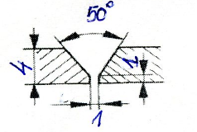 | 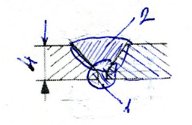

Welding technology data:
Seam layer | Welding  process  number | Welding method | Welding data |  |  |  |  | Filler material
Seam layer | Welding  process  number | Welding method | Nozzle size,  Ø  mm | Combustible gas type | Acetylene  pressure,  MPa | Oxygen  pressure  MPa | Flame type | Mark | Size  Ø  mm
2 | 311 | rw | 3 | C₂H₂ | 0,05 | 0,25 | neutral | OIV | 3

Heat treatment after welding: none
Time, temperature, method: -
Heating and cooling speed: -
Comment:
………………………………
Manufacturer
(Name, date, signature)
Table 7.1. Manufacturer's welding instructions (WPS) for gas welding of steels

The ISO 15608 standard classified the most commonly used steels for welding into steel groups. The standard also includes material groups for Al and its alloys, Cu and its alloys, Ni and its alloys, Ti and Zr and its alloys, as well as cast iron. In the WPS, the international designation of the material to be welded and the number of the material group must also be indicated. P235TR1 is a low C content (≤ 0.16%), low Mn content (0.35%) seamless unalloyed steel tube, minimum yield strength ReH=235 MPa, tensile strength Rm=360-500 MPa, minimum elongation at break 25%. Table 7.2. summarizes the material groups that can be used for gas welding. The raw material of the pipe is 1.1. belongs to the group, so this must be indicated in the WPS. Steel can be welded well, so there is no need for preheating or post-heat treatment. The feed material – 6.5. according to the Table 6.5. –can be OI-OIV, the seam must be welded in 2 layers, welding to the right.

Steel group | Steel group
1. | R_{eH} ≤ 460 N/mm² lowest yield point and the next compound (%) steels: C≤0,25; Si≤0,60; Mn≤1,7; Mo≤0,70; S≤0,045; P≤0,045; Cu≤0,40; Ni≤0,5;  Cr≤0,3; (cast ironsl 0,4); Nb≤0,05; V≤0,121; Ti≤0,05
1.1 | R_{eH} ≤ 275 N/mm² előírt lowest yield point steels
1.2 | 275 < R_{eH} ≤ 360 N/mm² lowest yield point steels
1.3 | normalized fine-grained steels R_{eH} > 360 N/mm²
1.4 | incorrodible steels, the quantity of each elements < 1 %
5. | V-free, Cr-Mo steels C ≤ 0,35 %
5.1 | Steels 0,75 % ≤ Cr ≤ 1,5 % és Mo ≤ 0,7 %
Table 7.2. Steel groups and steel types (excerpt)

4.3. Personal conditions of gas welding
Welding can be done independently by anyone
- turned 18 and
- according to the relevant legislation*, he is suitable for the task based on a preliminary and temporary occupation based on a health and aptitude test, and
- has a state-recognized welding qualification and a successful fire protection examination;
- has a valid "welding certificate" (qualification) for the procedure covered by the regulation;
- in the absence of qualification and certificate, has a successful welding occupational safety examination.

4.4. Qualification of gas welders

7.1. in order to perform the welding work shown in the table, the welder must have the following valid certification according to the EN 287-1 standard:
 | 1 | 2 | 3 | 4 | 5 | 6 | 7 | 8 | 9 | 10
EN 287-1 | 311 | T | BW | 1.1. | S | t04 | D38 | PH | ss | nb | ml | rw

The terms indicated in the rating are defined in Table 7.3. summarizes.

Welding process | Type of product | Seam type | Material group | inert material | Material thickness, mm | Tube diameter, mm | Welding pozition | Welding methods
1 | 2 | 3 | 4 | 5 | 6 | 7 | 8 | 9 | 10
311 | P  T | BW  FW | 7.2.  table | nm  S | t… | D… | 3.6.ábra | ss  bs | nb  mb  sl  ml  lw  rw

Table 7.3. Possible classification of gas welders for steels

1 Welding process number

2 Product type 3 Seam type 4 Material group
P plate BW butt seam
pipe FW corner seam

5 Material
6 Material thickness, t mm
7 Pipe outer diameter, D, mm
nm without filler material
S solid wire/stick

8 Welding position
9 Welding execution method
ss welding from one side
bs welding on both sides

10 Welding method
nb welding with fusible pad without scar bath support
mb welding with fusible pad with scar bath support
sl single layer
ml multilayer
lw left welding
rw right welding

Repeating and checking questions

1. What are the quality requirements for bulk welding of metals?
2. What is meant by manufacturer's welding instructions and why a WPS is necessary
make it?
3. What are the personal requirements for gas welding?
4. What steel groups are used in gas welding?
5. How is a gas welding qualification structured?

5. GAS WELDING SAFETY TECHNOLOGY, ENVIRONMENTAL PROTECTION
5.1. Safe design of the workplace

The following are the general requirements for the welding workplace:
1. Adequate space must be available
- to carry out the work safely (the workpiece must be passable);
- for the treatment of welding tools, devices, welding equipment,
possible on-site quick repair;
- for the storage of parts, assembled units (stroke storage), work tools:
- the daily welding material and auxiliary materials used for work are professional and appropriate
protective storage;
- for storing finished products:
- for storing personal protective equipment;
- for inspection and examination;
- to change the location of material handling equipment;
- to store production documentation, drawings and operating instructions during work
for posting.
2. The workplace conditions should enable calm, undisturbed work. Adequate lighting, ventilation, noise protection, and power supply should be provided.
3. The workplace must meet the occupational and health protection requirements.
4. The power supply of welding tools, devices, and welding equipment should be reliable and safe. Larger voltage fluctuations are not allowed, the supply network must be suitable for transmitting the necessary electrical power, and the gas supply system must comply with safety and operating regulations. Gas welding and related processes can be carried out at a fixed workplace, in a closed space, as well as outdoors, at a changing location. The area requirement of the installed workplace is usually at least 4 m², which must be separated from the environment with light absorbers. It is advisable to set the ambient temperature to 18−20°C. Welding activities in non-installed workplaces can only be carried out if there is a fire permit. One of the important conditions for accurate work is good lighting and a bright environment. The minimum lighting requirement is 300 lux. Due to the fire hazard of welding, the floor and the bordering walls must be made of non-combustible material, and only flame-resistant light-absorbing curtains can be used for flexible demarcation. It must also be ensured that only the absolutely necessary persons are nearby when performing activities in a dangerous environment. In case of increased fire risk, the presence of a fire extinguisher must also be requested. Welding and cutting tools and devices must be placed in such a way that they do not hinder work, material handling, relocation - and rescue in the event of an accident. When designing the workplace, it may be necessary to use protective barriers, foot grates and other protective devices. Their use is especially justified when welding in a pit or at a height on a stand. Outdoor work must be protected against the elements. It is advisable to protect the welder and his equipment against the hot sun and precipitation with a mobile (detachable protective roof or tarpaulin) roof structure.

Welding carried out in narrow, closed spaces, rooms (closed, small spaces of tanks, boilers, other pressure vessels) hide increased dangers for the welder working in them. In addition to the poisoning caused by the lack of oxygen, the enrichment of combustible gas, and the accumulated air pollutants, there is a significant risk of fire, which can be avoided by preventing the formation of a flammable mixture. Therefore, working in such a space is only permitted if, in addition to ensuring ventilation, the welder is also equipped with an individual respiratory protective device. There is also a need for a supervisor who, outside of the confined space, monitors the welder's activities, the supply of clean air, and, if necessary, contributes to the rescue. It is forbidden to bring gas cylinders and welding current sources into a narrow, closed space and operate them there; these must be placed outside the closed space. For rescue, it is necessary to ensure the possibility of an emergency signal and the continuous wearing of the life belt.

5.2. Fire protection
Welding, soldering, thermal cutting and thermal spraying, cutting, etc. glowing, flying particles (metal drops, slag, etc.) with significant heat energy are generated during the process, which ignite most flammable materials. Materials with high temperatures (500...800 °C) can often cause a fire by travelling a significant trajectory.
If you have to weld, solder or cut in a fire-hazardous environment, you must take preliminary measures to prevent accidents. It must be checked on the floor, walls, floor openings, doors and windows, etc. gaps in order to prevent a spark or other fire-causing material from accidentally falling onto a flammable material.
Such openings must be carefully closed and constantly monitored. A sufficient number of functional fire extinguishers, depending on the quality of the combustible material, must be placed at the welding or cutting workplace, and workers must be trained to operate them. The measures prior to welding and the regulations to be followed during the execution of tasks must be recorded in a welding permit. This written document contains the tasks to be done, the most important of which are:
- determination of materials and tools to be removed from the workplace,
- the need to suspend utility services (gas, electricity, steam),
- method of examination and control of the workplace environment,
- the openings to be sealed, wall penetrations, ventilators, electrical switch cabinets, etc.
compilation of the list,
- checking the workplace environment after welding and cutting work,
determining the need for supervision.
After finishing the welding and cutting work, the environment and the workplace must be inspected after the workpiece has cooled down. The control, or supervision must be maintained continuously for up to 6-8 hours, depending on the nature of the task. Only then can the original working condition be restored.
During the welding of equipment for the storage of flammable and explosive materials, the equipment must be thoroughly cleaned, washed, and dried before starting work so that no deposits or dirt remain in them. The structure prepared in this way must be filled with steam, water or neutral gas during welding. Fire-fighting and first-aid equipment must be placed near the workplace, and personal protective equipment must be supplemented as necessary (gas mask, fresh air breathing apparatus, etc.). If it is not possible to empty the large pressure vessel or pipeline, first of all, the pressure of the system must be reduced to the lowest possible value, which is even greater than that of the environment. When organizing the workplace, the conditions for starting a fire, rescue and first aid must be created. A welder with appropriate qualifications and extensive experience should perform such work, and the welder in charge (work supervisor) must also be on site together with the personnel providing the work.

5.3. Welding fumes
At welding, soldering, thermal cutting and spraying workplaces - as well as in their narrower and wider surroundings - smoke formation and air pollution must also be expected. During welding and cutting, depending on the process, different amounts of gases (formaldehyde and acetaldehyde, phenol, CO, nitrous gases, etc.) and vapors are produced.
Health-damaging smoke and dust concentrations increase with increasing plate thickness and cutting speed, especially during flame cutting. The maximum concentration of individual welding fume components that can be measured in the worker's breathing zone is recorded by the MAK values ​​(Maximum Workplace Concentration). According to today's knowledge, these limits do not cause illnesses at 8 hours, assuming a 40-hour work week. The harmful effects of welding fumes occur during bulk welding, flame cutting, plasma welding and cutting, and metal spraying in a narrow, closed room. Some of the gases produced (e.g. ozone, phosgene, nitrogen dioxide) can cause serious poisoning. As a result, shortness of breath and coughing may occur. The person suffering from poisoning must be taken to fresh air and given medical care.

5.4. Ventilation of workplaces
The formation of health-damaging gases and solid impurities in the workers' environment can be reduced by proper organization of gas welding and flame cutting work and careful work. The work must be carried out in such a way that the harmful substances formed avoid the welder's breathing zone, thus preventing direct inhalation. The increased protection of the welder can be solved by exhausting, and the replacement of fresh air by ventilation. Air exchange must be ensured to such an extent that a dangerous gas concentration cannot develop.
If the smoke concentration - despite natural air exchange - reaches 9 mg/m3, ventilation must be provided. The most obvious solution is local extraction, which can be fixed or mobile. The air from the work area can be led directly to the outdoors or the flue gases can be filtered by passing them through a coarse and a fine filter and then returned to the workplace. By using it, the costs of heating the supplementary air can be saved. A widespread version of the artificial ventillation of the workplace is the general ventilation of the entire plant. For this, high-performance fans mounted on the roof or in the wall are used. Fresh air is either blown into the workshop from below and extracted from above, or - incorrectly - counter-flow ventillation is carried out.

5.5. Management of gas welding equipment
For gas welding equipment, only devices and gas lines whose conformity has been proven can be used: this is documented by the manufacturer's declaration of conformity, which is a condition for placing on the market. Conformity must be verified with a declaration of conformity referring to the test report issued by the accrediting testing site. Legislation requires the periodic control review of welding-related work equipment. According to the legislation, the employer shall carry out it with a frequency and content determined within his own authority. Its purpose is to check whether the assembly of the welding equipment is correct or not. Whether the safety functions required under the given circumstances are functional. The frequency of the periodic safety inspection required by the Welding Safety Regulations varies between ¼ and 3 years, depending on the type of device.
A person who is not authorized to weld can handle a gas cylinder if he has acquired the necessary knowledge in the course of training. The training can be carried out by a person in charge of welding employed by the business organization or by an authorized welding officer (IWE, IWT, IWS) or by an accredited institution.

Gas welding and flame cutting devices, the associated central gas supply pipeline system, and other gas sources may only be operated with safety fittings that protect against dangerous reactions (flame backflow preventer, non-return valve, water seal). All gas sources must be equipped with nameplates and gas flow indicators. Oil and grease must be removed from oxygen gas sources and devices in contact with oxygen. All equipment that comes into contact with oxygen must be labeled "Do not come into contact with oil and grease!" It is forbidden to use oxygen together with compressed air, or to replace compressed air with oxygen or oxygen with air! Gas cylinders must be protected from direct heat (e.g. sunlight, heaters) by shading or covering them. The external temperature of the gas cylinder must not exceed 50º C. The gas cylinder must be secured against tipping and displacement. Gas cylinders must be prevented from freezing (e.g. to the ground, floor, stand). Frozen gas cylinder max. It may be thawed with water at a temperature of 40ºC. The angle of inclination of a gas cylinder containing dissugate gas may not be greater than 30º from the vertical when in use. The gas cylinder cannot become part of the circuit, the user is prohibited from making any repairs or changes to the gas cylinder!
If the consumption of acetylene gas exceeds the value of 500 liters/hour/bottle, the conditions for a safe gas supply must be ensured with technical measures (bottle station, stack of bottles, etc.). Gas and gas mixtures can only be filled in gas cylinders by an officially approved filling station. Gas cylinders must be stored separately by type of gas, empty and full, only in places where the presence of combustible and easily flammable materials is excluded. You may only store and transport gas-tight, sealed gas cylinders with a valve cap that is screwed on in the case of cylinders with a valve cap. If the valve of the gas cylinder cannot be opened manually, it must be returned to the filling station. The gas cylinder must be marked with the error (e.g. sign, chalk inscription). It is forbidden to use a gas cylinder for other purposes (e.g. as a support or for transport, as a transport roller)! The welding workplace can only have as many gas bottles as are necessary for continuous work. Only gas-tight, flawless and undamaged hoses may be used. The length of the rubber hose that can be used is at least 5 m, but not more than 30 m. The rubber hose must only be attached to the hose ends with a tape clamp, and it can only be spliced with a double hose connector.

5.6. Personal protective equipment
The selection of personal protective equipment to be used for welding and related processes must be preceded by a risk analysis for the work in question, and for this the specialists responsible for the health and safety of employees cannot do without the cooperation of the welding specialists (welding supervision), especially in determining the current risks. Personal protective equipment must be used when there is no other way to effectively protect and reduce risks (fencing, paving, use of safe technology, etc.). When gas welding, e.g. the use of welding goggles with a suitable light filter is sufficient to protect the eyes. On the other hand, flame cutting involves strong spatter and sparks, so it is recommended to use a face mask in addition to welding goggles. The task of welding filters is to reduce the harmful radiation reaching the eyes to a safe level. The desired filtration level can be determined depending on the acetylene consumption (l/h) for gas welding and the oxygen consumption (l/h) for flame cutting. The individual protective clothing of the welder consists of closed work clothes or flame-resistant protective clothing, leather apron, leather arm guards, leather gloves, and leather leg guards. Eye protection equipment includes glasses with frames or glasses with a headband (closed eye protection) and a face shield. If necessary, you must wear ear protection to protect your hearing, respiratory protection devices to protect your breathing, and welding filters to protect against radiation.

5.7. Environmental protection
Welding and cutting pose an environmental risk to the working environment in the narrower sense and to the built environment in a broader sense. Depending on the composition of the coating, a large amount of smoke must be expected when welding and cutting workpieces with temporary corrosion protection. During thermal cutting processes and thermal spraying, in addition to the already mentioned health-damaging substances, metal vapors are also produced. In addition to extraction with a filter insert, several technical options are available to filter out harmful substances. Thus, in addition to cutting tables with a gravity trap, in the case of plasma cutting, cuts using a water medium can be a solution, which, however, can be accompanied by a reduction in cutting performance.

Repeating and checking questions
1. What are the main requirements for the welding workplace?
2. What regulations must be followed for the storage of flammable and explosive materials
suitable for tank welding?
3. What is a fire permit and what does it contain?
4. How can you protect yourself against the health-damaging effects of welding fumes?
5. What regulations apply to the storage of gas cylinders?
6. What regulations apply to the handling of gas cylinders?
7. What regulations apply to welding carried out in narrow, closed spaces,
for cutting work?
8. What dangers can occur when soldering metals?
9. What dangers can occur when flame cutting metals?
10. What should be taken into account when thermal spraying metals?

