MIG and MAG Welding Manual

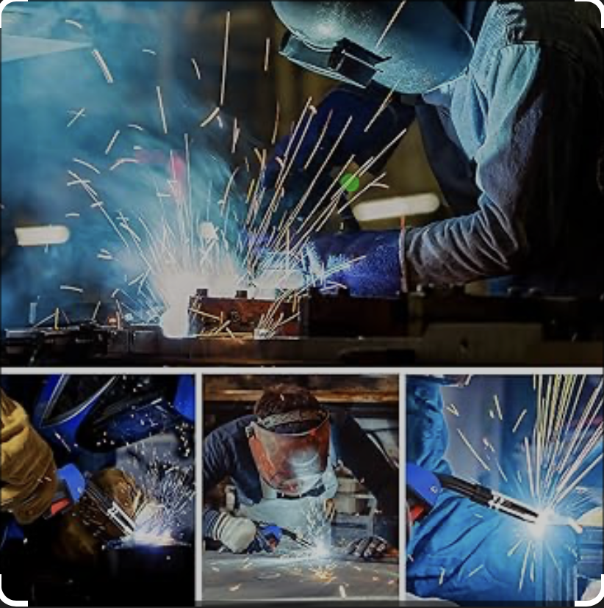

1. Introduction
- Definition of MIG (Metal Inert Gas) and MAG (Metal Active Gas) welding
- Common applications and industries
- Advantages and limitations

2. Principles of Operation
- Arc formation between a continuously fed wire electrode and the workpiece
- Role of shielding gas in preventing oxidation
- Difference between MIG and MAG gases:
- MIG: inert gases (argon, helium, or mixes) for non-ferrous metals
- MAG: active gases (CO₂ or argon-CO₂ blends) for ferrous metals

3. Equipment Overview
- Welding machine (power source)
- Wire feeder
- Welding torch (gun)
- Shielding gas supply
- Ground clamp

4. Safety Precautions
- Eye protection and welding helmet
- Fire-resistant clothing and gloves
- Proper ventilation to avoid inhalation of fumes
- Electrical safety
- Handling and storage of gas cylinders

5. Consumables
- Wire types and diameters
- Gas types and flow rates
- Contact tips and nozzles

6. Preparation for Welding
- Cleaning the workpiece (removing rust, paint, oil)
- Setting parameters (voltage, amperage, wire speed)
- Choosing correct polarity (DCEP for most MIG/MAG)
- Gas flow adjustment

7. Welding Techniques
- Torch angles (push vs. pull)
- Travel speed and bead formation
- Stringer vs. weave beads
- Tack welding for joint alignment
- Vertical, horizontal, flat, and overhead positions

8. Common Weld Defects and Troubleshooting
- Porosity (causes and solutions)
- Lack of fusion
- Spatter
- Burn-through
- Undercut

9. Maintenance of Equipment
- Cleaning nozzles and contact tips
- Checking liner and wire feed mechanism
- Gas hose inspections
- Periodic calibration of the machine

10. Glossary of Terms

1. Introduction
MIG (Metal Inert Gas) and MAG (Metal Active Gas) welding are two variations of the Gas Metal Arc Welding (GMAW) process, a highly efficient and versatile method for joining metals. Both techniques use a continuously fed consumable wire electrode and a shielding gas to protect the molten weld pool from atmospheric contamination.
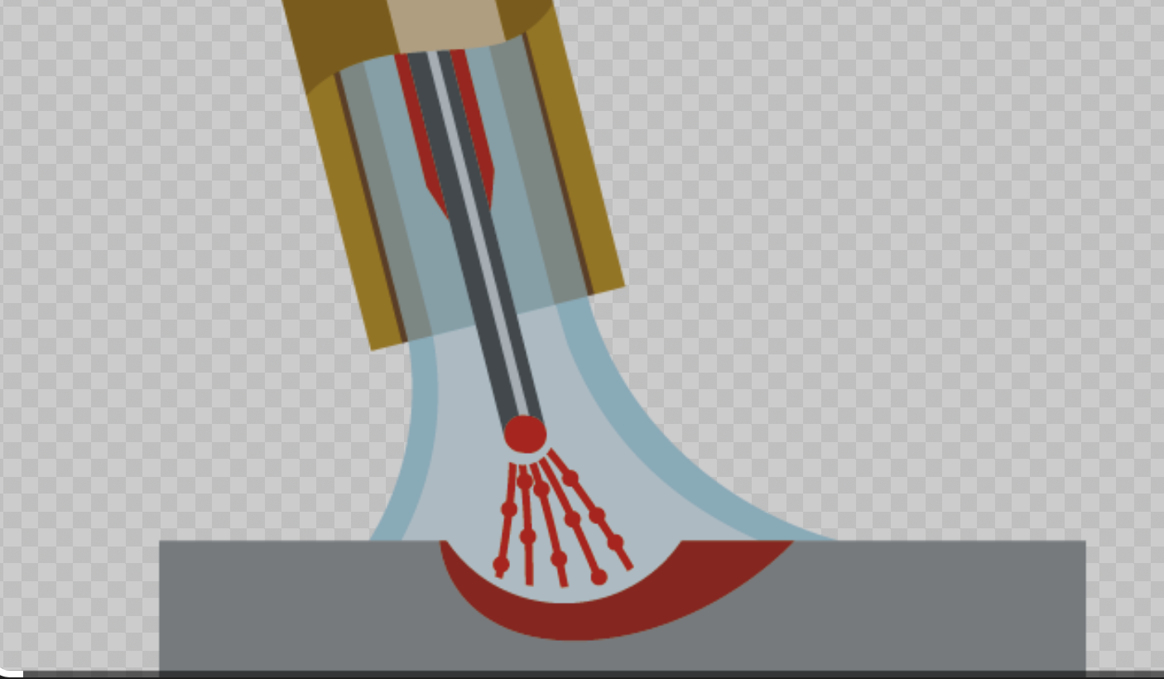
The main distinction between MIG and MAG welding lies in the type of shielding gas employed:
- MIG welding uses inert gases such as argon, helium, or their mixtures. These gases do not react with the molten metal and are typically used for welding non-ferrous materials such as aluminium, copper, and stainless steel.
- MAG welding uses active gases, such as carbon dioxide (CO₂) or mixtures of argon and CO₂. These gases interact chemically with the molten weld pool and are mainly used for welding carbon steels and low-alloy steels.
Because of their high deposition rates, relative ease of use, and adaptability to various materials and thicknesses, MIG and MAG welding are widely used in industries such as automotive manufacturing, shipbuilding, construction, and general fabrication. They are suitable for both manual and automated welding operations.
In comparison to traditional processes such as Shielded Metal Arc Welding (SMAW), MIG/MAG welding offers:
- Higher welding speeds
- Less post-weld cleaning due to reduced slag formation
- Continuous wire feed for uninterrupted operation
- The ability to weld in multiple positions
However, the quality of the results depends on correct setup, proper technique, and adherence to safety procedures. This manual will provide comprehensive guidance on operating MIG and MAG welding equipment, understanding process parameters, ensuring workplace safety, and troubleshooting common welding issues.

2. Principles of Operation
MIG (Metal Inert Gas) and MAG (Metal Active Gas) welding are both forms of Gas Metal Arc Welding (GMAW), in which an electric arc is established between a continuously fed wire electrode and the workpiece. The heat generated by the arc melts both the electrode wire and the base metal, creating a molten pool that solidifies to form a strong weld joint.
2.1 The Arc Welding Process
- Wire Feeding – A motor-driven system pushes the consumable wire electrode through the welding torch and into the weld area.
- Arc Formation – When the wire touches the workpiece and the trigger is pressed, an electric arc forms, generating intense heat (typically 3,000–6,000 °C).
- Metal Transfer – The molten electrode material is transferred into the weld pool.
- Solidification – The molten metal cools and solidifies, forming the weld bead.
2.2 The Role of Shielding Gas
Shielding gas flows through the welding torch and envelopes the weld pool, protecting it from contamination by atmospheric gases such as oxygen, nitrogen, and water vapour, which can cause porosity and brittleness.
- MIG Welding – Uses inert gases (argon, helium) that do not chemically react with the molten metal. Ideal for non-ferrous metals.
- MAG Welding – Uses active gases (CO₂, or argon/CO₂ blends) that influence arc characteristics and penetration profile, making them suitable for steels.
2.3 Metal Transfer Modes
Depending on wire type, gas composition, and electrical parameters, the molten metal can transfer from the electrode to the weld pool in different ways:
- Short-Circuit Transfer – The wire touches the molten pool, creating a short circuit. Best for thin materials and out-of-position welding.
- Globular Transfer – Larger metal droplets form and fall into the weld pool. Less controlled, more spatter, usually with pure CO₂.
- Spray Transfer – Fine droplets are sprayed across the arc, producing smooth welds with deep penetration. Requires higher voltage and argon-rich gas.
- Pulsed Spray Transfer – Alternates between high and low current, allowing spray transfer at lower average heat input, useful for thin metals.
2.4 Direct Current Electrode Positive (DCEP)
MIG/MAG welding generally uses DCEP polarity, where the wire electrode is connected to the positive terminal and the workpiece to the negative terminal. This polarity produces deeper penetration and a more stable arc.
2.5 Process Summary
In essence, MIG and MAG welding combine continuous wire feeding, a stable electric arc, and shielding gas protection to produce high-quality welds quickly and efficiently. Mastery of the process requires understanding how electrical settings, wire type, and shielding gas interact to influence weld quality and performance.

3. Equipment Overview
MIG and MAG welding systems consist of several key components that work together to produce a controlled and consistent welding process. Understanding the function of each part is essential for proper setup, operation, and maintenance.
3.1 Welding machine (power source)
The welding power source supplies the electrical energy needed to create and sustain the arc.
- Type: Most MIG/MAG machines use a constant voltage (CV) power supply, which maintains a steady voltage while the current adjusts automatically based on wire feed speed.
- Polarity: Typically operated in Direct Current Electrode Positive (DCEP) for better arc stability and penetration.
- Control Panel: Allows adjustment of voltage, wire feed speed, and sometimes additional features such as inductance control or pulsing functions.

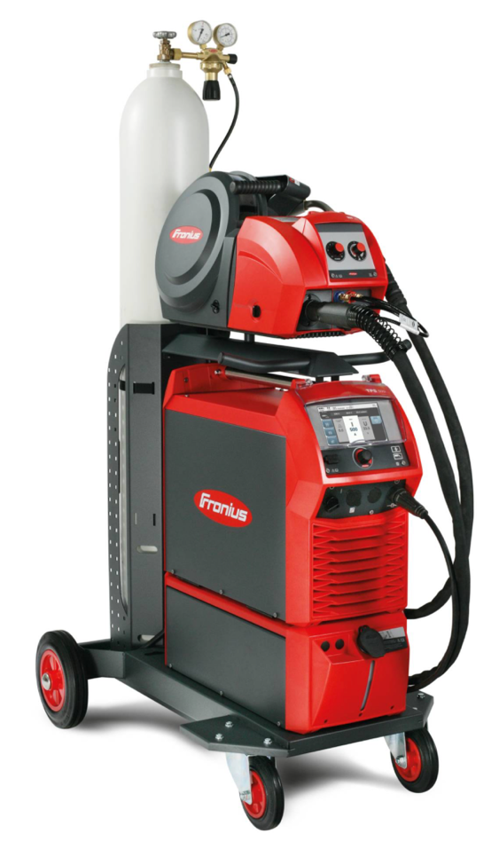
3.2 Wire Feeder
The wire feeder delivers the consumable wire electrode to the welding torch at a controlled rate.
- Drive Rolls: Grip and push the wire through the torch cable. The groove type must match the wire diameter and material.
- Speed Control: Wire feed speed affects amperage and deposition rate.
- Spool Holder: Accommodates wire spools, typically weighing from 1 kg to 15 kg.
3.3 Welding Torch (gun)
The torch directs the electrode wire, shielding gas, and electrical current to the weld area.
- Trigger Switch: Activates both wire feed and shielding gas flow.
- Nozzle: Channels shielding gas toward the weld pool.
- Contact Tip: Transfers electrical current to the wire electrode; must match wire size for optimal conductivity.
- Liner: Guides the wire through the torch cable to the contact tip.
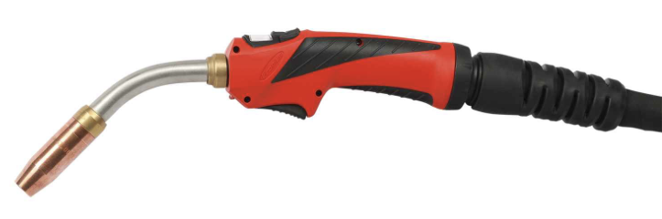
3.4 Shielding Gas Supply
The gas system protects the weld pool from atmospheric contamination.
- Gas Cylinder: Stores the shielding gas under high pressure.
- Regulator/Flowmeter: Controls gas flow rate, typically between 10–20 liters per minute (L/min), depending on joint design and environment.
- Gas Hose: Connects the cylinder to the wire feeder or power source.

3.5 Ground (Work) Clamp
Completes the electrical circuit between the power source and the workpiece.
- Must be securely attached to clean, bare metal for stable arc performance.
- Poor connections can cause arc instability, spatter, and excessive heat buildup in the clamp.
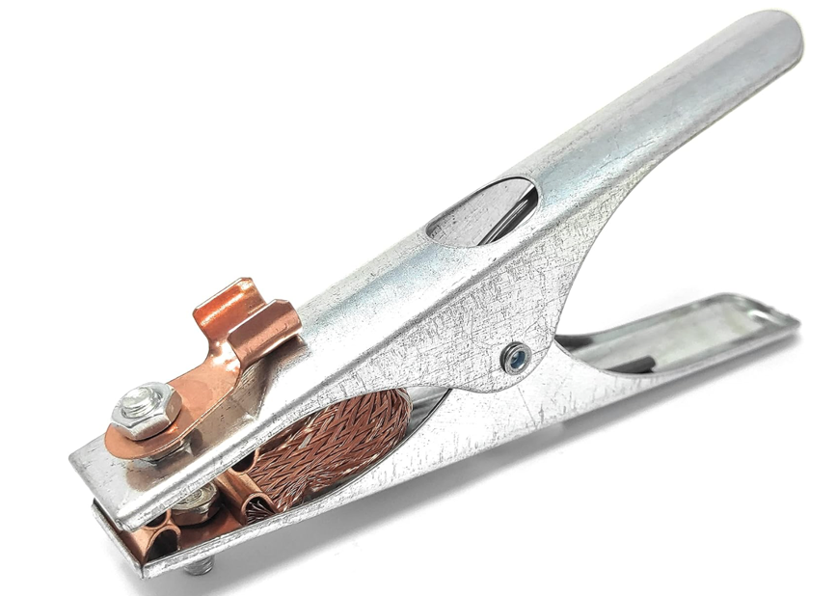
3.6 Optional Accessories
- Spool Gun: For welding aluminium with shorter wire feed paths.
- Water-Cooled Torch: For high-amperage applications to prevent overheating.
- Fume Extraction System: To maintain safe air quality in enclosed spaces.

4. Safety Precautions
MIG and MAG welding involve high temperatures, intense light, electrical currents, and potentially hazardous fumes. Proper safety measures are essential to protect the operator, other personnel, and the work environment.
4.1 Personal Protective Equipment (PPE)
- Welding Helmet: Use a helmet with an appropriate filter shade (typically shade 10–13) or an auto-darkening lens to protect against arc rays and intense brightness.

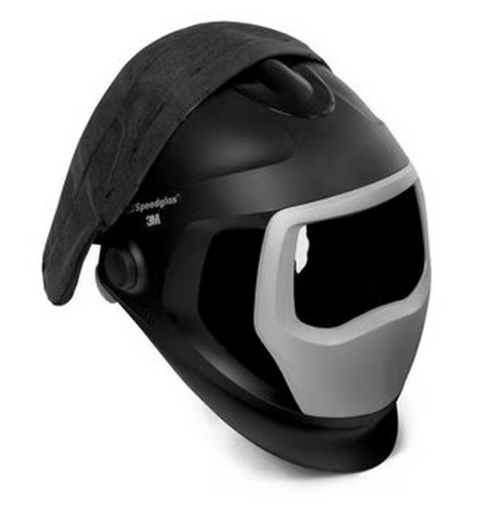

- Protective Clothing: Wear flame-retardant jackets, aprons, and trousers. Avoid synthetic fabrics that can melt onto skin.


- Gloves: Use heavy-duty, heat-resistant leather welding gloves.
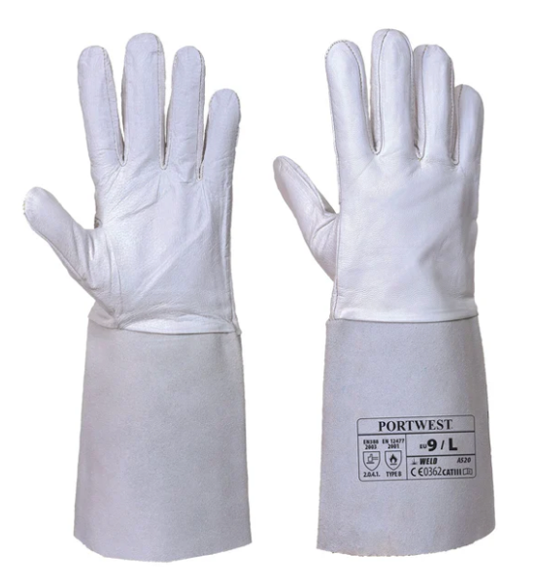

- Footwear: Wear safety boots with non-slip soles and steel toes.
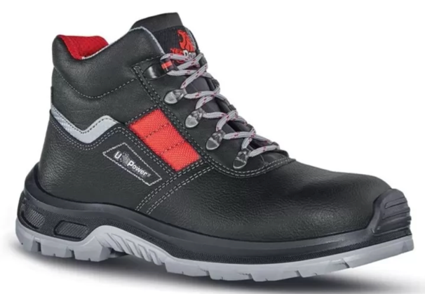

- Eye and Face Protection for Grinding: Use safety goggles or a face shield when preparing workpieces or removing weld spatter.
4.2 Protection from Arc Radiation
- UV and IR Radiation: The welding arc emits ultraviolet (UV) and infrared (IR) radiation, which can cause severe eye and skin burns.
- Work Area Shielding: Use welding curtains or screens to protect nearby workers from exposure.
4.3 Electrical Safety
- Proper Grounding: Ensure the work clamp is securely attached to clean metal.
- Insulation: Keep cables and torch leads in good condition; replace damaged insulation immediately.
- Dry Conditions: Avoid welding in wet or damp environments to reduce shock risk.
- Machine Maintenance: Only qualified personnel should service electrical components.
4.4 Fire and Explosion Prevention
- Remove Flammable Materials: Clear the work area of combustible liquids, gases, and solids.
- Fire Watch: Assign a fire watch when welding in hazardous environments.
- Hot Work Permits: Follow site regulations for hot work in restricted areas.
- Gas Cylinder Safety: Store cylinders upright, secured, and away from heat sources.
4.5 Fume and Gas Control
- Ventilation: Use local exhaust ventilation or fume extraction systems.
- Respiratory Protection: In confined spaces or poor ventilation, use approved respirators.
- Gas Awareness: Shielding gases can displace oxygen; monitor oxygen levels in enclosed areas.
4.6 Safe Handling of Gas Cylinders
- Transport: Use proper cylinder trolleys; never roll or drag cylinders.
- Valve Protection: Keep valve caps in place when not in use.
- Leak Checks: Regularly inspect for leaks using soapy water (never open flame).
4.7 General Safe Work Practices
- Keep the work area clean and well-lit.
- Maintain clear access to emergency exits and fire extinguishers.
- Never leave the welding torch active and unattended.
- Follow manufacturer instructions for all equipment and consumables.

5. Consumables
In MIG and MAG welding, consumables are materials that are used up during the process and must be replaced periodically. Selecting the right consumables is critical to achieving strong, defect-free welds and maintaining consistent productivity.
5.1 Welding Wire
The wire electrode acts both as a filler material and as the conductor for the arc.
Types of wire by material:
- Mild Steel: Usually copper-coated to reduce oxidation and improve electrical contact. Common diameters: 0.8 mm, 1.0 mm, 1.2 mm.
- Stainless Steel: Requires corrosion-resistant alloys; often used with argon-rich shielding gas.
- Aluminium: Soft wires (e.g., ER4045, ER5356) require special feeding systems such as spool guns or push–pull feeders.
- Flux-Cored Wire: Contains flux for shielding, allowing welding without external gas or with reduced gas requirements.
Diameter selection:
- Thin materials: 0.6–0.8 mm
- Medium thickness: 1.0 mm
- Heavy sections: 1.2 mm or larger
5.2 Shielding Gases
Shielding gases protect the molten weld pool from atmospheric contamination.
- MIG Welding (Inert Gases):
  - Argon: Stable arc, smooth welds, used for aluminium, copper, and stainless steel.
  - Helium: Increases heat input, used for thick non-ferrous metals.
  - Argon/Helium mix: Balances penetration and bead appearance.

- MAG Welding (Active Gases):
  - CO₂: Deep penetration, more spatter; cost-effective for steels.
  - Argon/CO₂ mix: Reduced spatter, improved arc stability.
  - Argon/CO₂/O₂ mix: Enhanced wetting and bead shape for structural steel.
Flow rate: Generally, 10–20 L/min, adjusted for environment and joint type.
5.3 Contact Tips
- Function: Transfers electrical current from the torch to the wire electrode.
- Material: Usually copper or copper alloys for good conductivity.
- Sizing: Must match wire diameter precisely (e.g., 1.0 mm wire → 1.0 mm contact tip).
- Wear: Replace when the hole becomes oversized or shows excessive burnback damage.
5.4 Nozzles
- Purpose: Directs shielding gas flow to the weld pool.
- Types: Cylindrical or tapered, depending on access and bead profile.
- Maintenance: Keep free from spatter using anti-spatter spray or dip.
5.5 Liners
- Role: Guide wire through the torch cable to the contact tip.
- Material: Steel liners for steel wires; Teflon or nylon liners for aluminium to prevent wire shaving.
- Care: Keep clean and replace when contaminated with dust, dirt, or metal shavings.
5.6 Drive Rolls
- Function: Feed the wire smoothly from the spool to the torch.
- Types:
  - V-groove: For solid wire.
  - Knurled: For flux-cored wire.
  - U-groove: For soft wires like aluminium.
- Adjustment: Correct tension prevents slipping or wire deformation.

6. Preparation for Welding
Proper preparation is essential for achieving strong, clean, and defect-free welds. Even the most advanced welding equipment cannot compensate for poor setup or contaminated work surfaces. This chapter covers the steps to prepare both the materials and the equipment before welding.
6.1 Workpiece Preparation
- Cleaning the Metal Surface
  - Remove rust, paint, oil, grease, and mill scale using a wire brush, grinder, or chemical cleaner.
  - Contaminants can cause porosity, lack of fusion, and poor bead appearance.
- Edge Preparation
- For thicker materials, bevel the edges to ensure full penetration.
- Common joint types include butt, lap, corner, edge, and T-joints.
- Fit-Up and Alignment
  - Position the workpieces according to the joint design.
  - Use clamps, magnets, or fixtures to hold parts in place.
- Tack Welding
- Apply small welds at intervals to hold parts together before the final pass.
- Prevents distortion and misalignment during welding.
6.2 Machine Setup
- Power Source Settings
- Adjust voltage and amperage according to material thickness, wire type, and shielding gas.
- Refer to the manufacturer’s parameter chart or welding procedure specification (WPS).
- Wire Feed Speed
- Controls the amperage and deposition rate.
- Too fast → excessive spatter; too slow → unstable arc and poor penetration.
- Polarity
- Use DCEP (Direct Current Electrode Positive) for most MIG and MAG applications.
- Inductance Control (if available)
- Adjusts the arc characteristics:
- Higher inductance → softer arc, less spatter.
- Lower inductance → crisp arc, more penetration.
6.3 Shielding Gas Setup
- Gas Selection
- Choose based on material type (see Chapter 5 for details).
- Flow Rate Adjustment
- Set between 10–20 L/min depending on nozzle size, joint configuration, and environmental conditions.
- Higher flow rates may be required outdoors or in drafty areas.
- Leak Check
- Inspect hoses, connections, and regulator for leaks before welding.
6.4 Torch Preparation
- Contact Tip
- Ensure it matches the wire diameter and is free from wear or blockages.
- Nozzle
- Keep clean from spatter buildup; use anti-spatter spray or dip as needed.
- Liner
- Check for smooth wire feeding; replace if contaminated or damaged.

6.5 Work Area Preparation
- Ensure adequate lighting and ventilation.
- Keep flammable materials away from the welding area.
- Arrange tools, clamps, and accessories for easy access.
- Place welding screens or curtains to protect others from arc flash.

7. Welding Techniques
MIG and MAG welding can produce strong, high-quality welds when correct techniques are applied. The operator must control torch position, travel speed, and bead formation to ensure proper penetration and a clean, consistent weld.
7.1 Torch Position and Angles
- Work Angle – The angle between the torch and the workpiece, measured across the width of the joint.
- Butt Joint: Typically, 90° to the workpiece.
- Fillet Joint: About 45° between the two plates.
- Travel Angle – The angle in the direction of travel.
- Push Technique (Forehand): Torch points in the direction of travel at 5–15°. Produces a flatter, wider bead with less penetration.
- Pull Technique (Backhand): Torch points back toward the weld at 5–15°. Produces deeper penetration and a narrower bead.
7.2 Travel Speed
- Too Fast: Narrow beads, lack of fusion, undercutting.
- Too Slow: Excessive heat input, wide beads, risk of burn-through.
Aim for a steady speed that maintains a consistent bead profile without excessive spatter.
7.3 Stickout (Electrode Extension)
- Distance from the contact tip to the arc, typically 10–15 mm for solid wire.
- Excessive stickout reduces penetration and causes arc instability.
7.4 Bead Types
- Stringer Bead: Straight-line movement without weaving; good for root passes and narrow joints.
- Weave Bead: Side-to-side motion to cover wider joints or build up layers; should be smooth and consistent to avoid defects.
7.5 Positional Welding
Different joint positions require adjustments in technique to control the weld pool:
- Flat Position (1G/1F): Easiest and most common; gravity assists bead formation.
- Horizontal Position (2G/2F): Control heat input to prevent sagging.
- Vertical Position (3G/3F):
- Vertical-up: Better penetration, used for thicker materials.
- Vertical-down: Faster travel, used for thin materials.
- Overhead Position (4G/4F): Keep a short arc length and fast travel speed to avoid molten metal dripping.
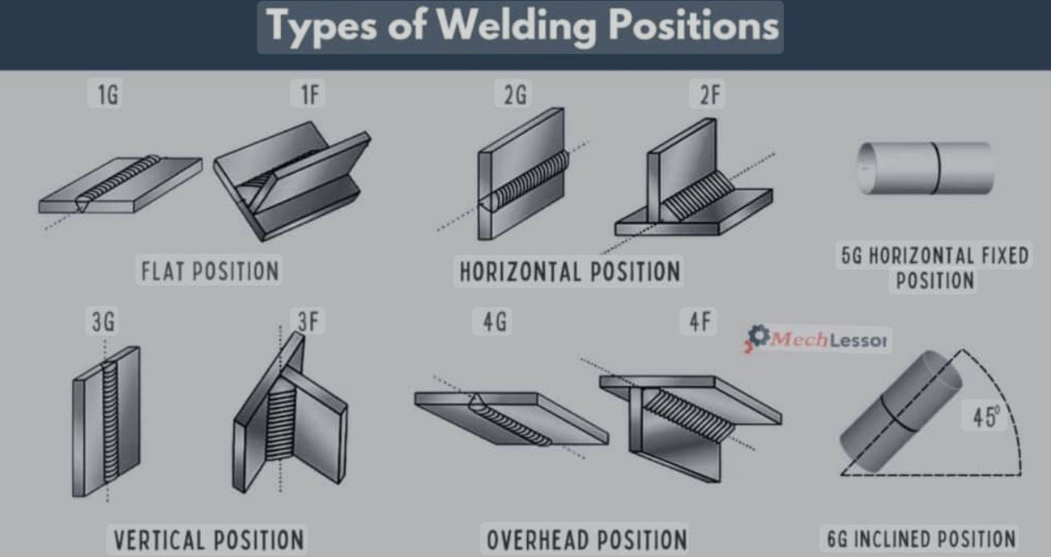
7.6 Starting and Stopping
- Start: Position the torch, squeeze the trigger, and pause briefly to establish the arc before moving.
- Stop: Reduce travel speed slightly, fill the crater, and release the trigger to avoid crater cracks.

7.7 Controlling the Weld Pool
- Keep the weld pool small for better control, especially in out-of-position welding.
- Watch the leading edge of the molten pool to guide your travel speed and direction.
7.8 Reducing Spatter
- Use correct voltage, wire feed speed, and gas flow.
- Maintain proper torch angle and stickout.
- Clean the workpiece and keep consumables in good condition.
Summary
Mastering MIG and MAG welding techniques requires practice and attention to torch position, movement, and speed. Consistency is key: a welder should aim to make each bead identical to the previous one, maintaining the correct parameters for the material and joint type.

8. Common Weld Defects and Troubleshooting
Even with proper preparation and equipment setup, weld defects can occur. Recognizing these issues early and understanding their causes is essential to maintaining weld quality and structural integrity. This chapter describes common MIG/MAG welding defects, their possible causes, and corrective actions.
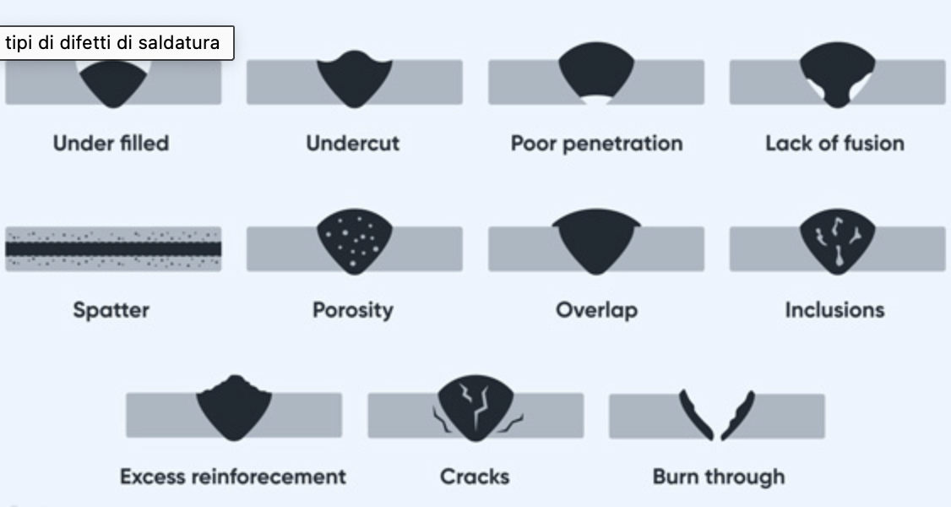
8.1 Porosity
Small holes or cavities within the weld caused by trapped gas.
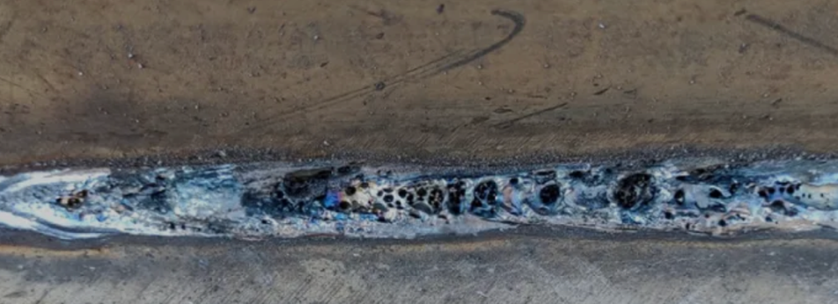
Causes:
- Contaminated base metal (oil, rust, paint, moisture).
- Excessive shielding gas flow creating turbulence.
- Inadequate gas coverage or leaks in the gas system.
- Welding in a drafty environment.
Solutions:
- Clean the workpiece thoroughly.
- Set correct gas flow rate (10–20 L/min).
- Inspect hoses, regulators, and torch for leaks.
- Use windshields or curtains to block drafts.
8.2 Lack of Fusion
Weld metal fails to fuse properly with the base metal or between passes.
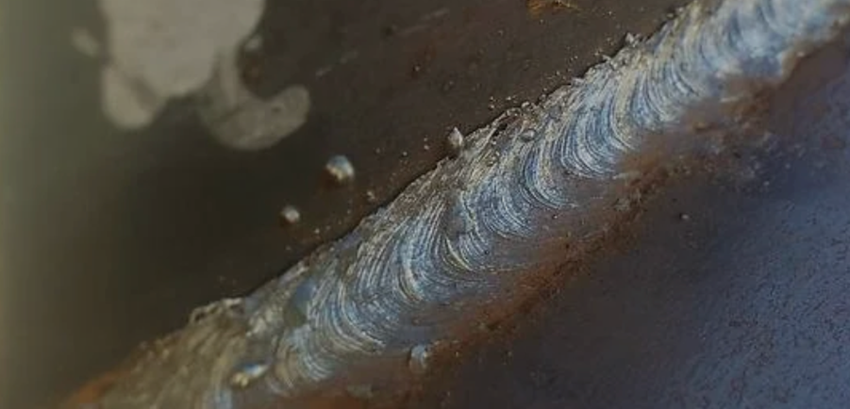

Causes:
- Travel speed too fast.
- Voltage too low or current insufficient.
- Improper torch angle.
- Dirty base material.
Solutions:
- Reduce travel speed.
- Increase voltage/amperage as per WPS.
- Maintain correct work and travel angles.
- Clean the joint area thoroughly.
8.3 Incomplete Penetration
Weld metal does not extend fully through the joint thickness.
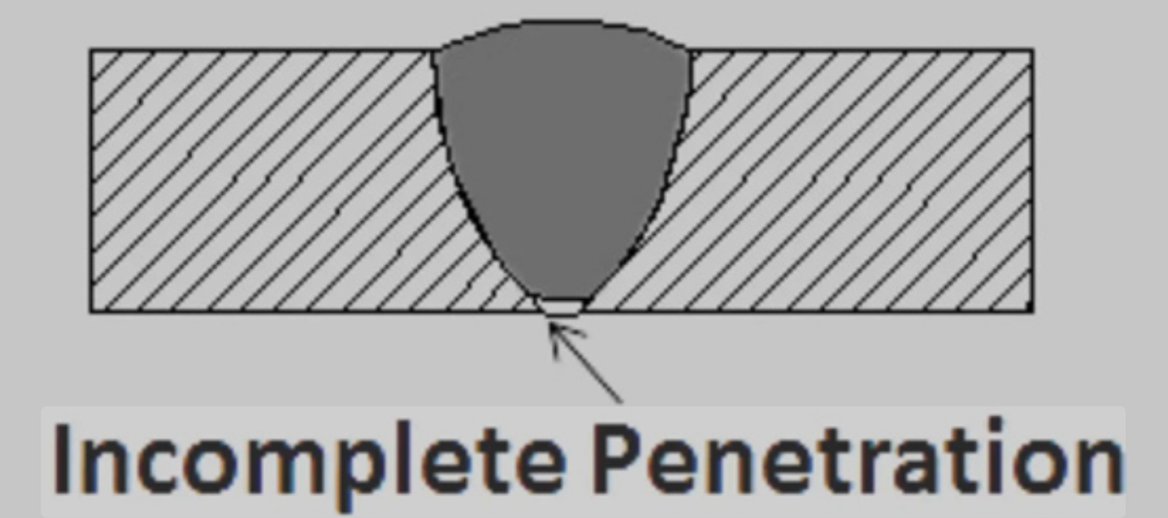
Causes:
- Heat input too low.
- Joint not properly prepared (narrow gap or incorrect bevel).
- Travel speed too fast.
Solutions:
- Increase heat input (voltage/amperage).
- Adjust joint preparation for adequate access.
- Reduce travel speed.
8.4 Spatter
Small molten metal droplets scattered around the weld.
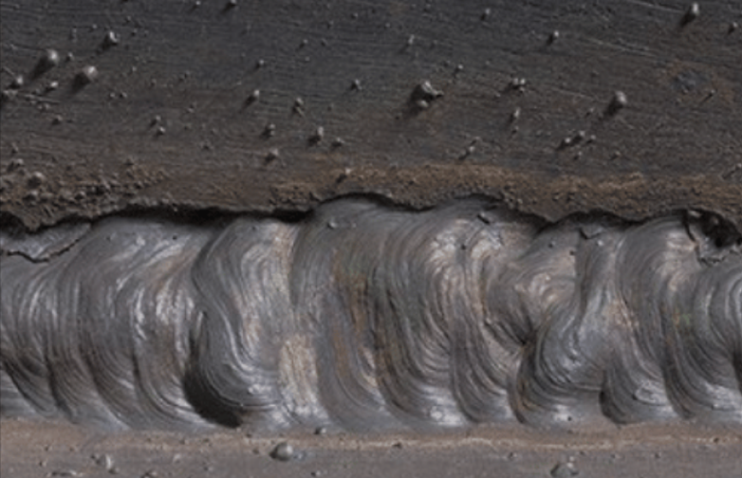
Causes:
- Incorrect voltage/wire feed settings.
- Excessive stickout.
- Poor shielding gas choice or flow.
Solutions:
- Adjust machine settings to match material and wire.
- Maintain proper stickout (10–15 mm).
- Use correct shielding gas mixture.
8.5 Undercut
Groove melted into the base metal along the weld toe, reducing strength.
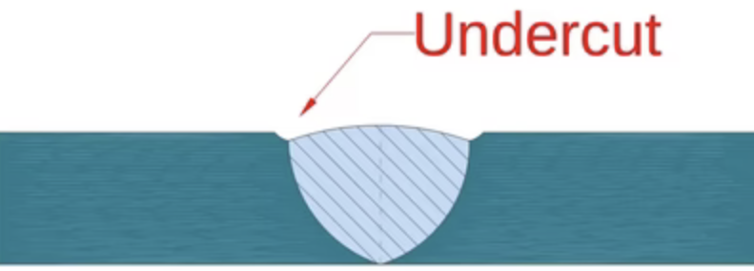
Causes:
- Travel speed too fast.
- Excessive voltage.
- Improper torch angle.
Solutions:
- Reduce travel speed.
- Lower voltage settings.
- Maintain correct torch position.
8.6 Burn-Through
Hole in the base material caused by excessive heat input.
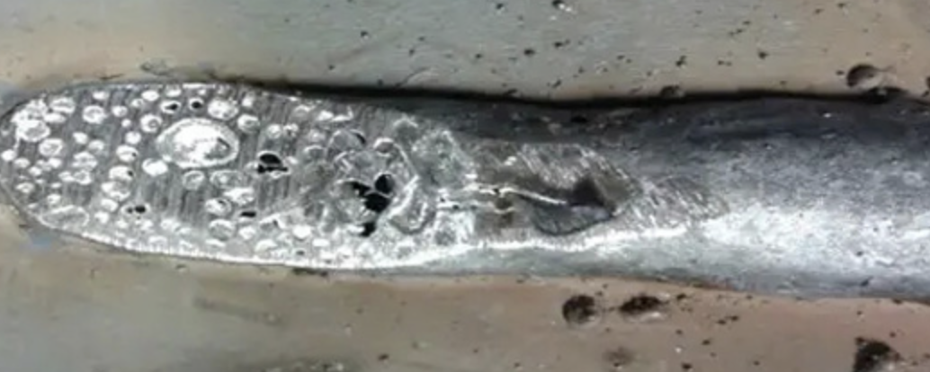
Causes:
- Voltage/amperage too high.
- Travel speed too slow.
- Thin base material with no heat control.
Solutions:
- Reduce voltage/amperage.
- Increase travel speed.
- Use pulsed spray transfer for thin materials.

8.7 Cracks
Fractures in the weld metal or heat-affected zone (HAZ).
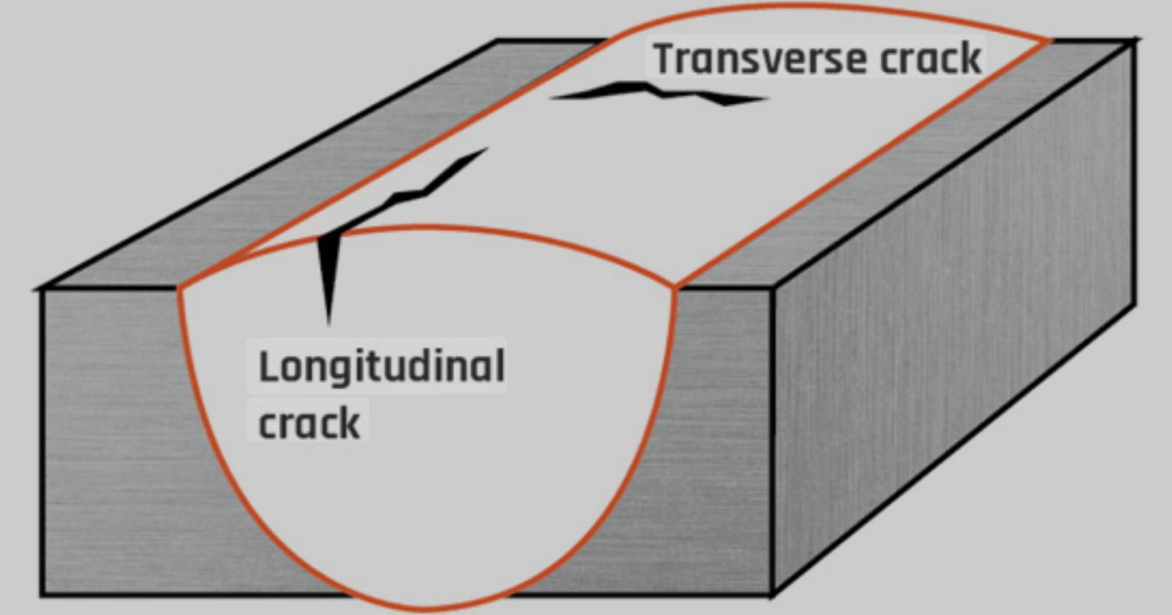
Causes:
- High residual stresses from rapid cooling.
- Contaminated materials.
- Poor joint design.
Solutions:
- Preheat thicker sections when needed.
- Use proper filler wire for the base metal.
- Modify joint design to reduce stress concentration.
Summary
Weld defects can compromise both the appearance and strength of a joint. By regularly inspecting welds, understanding the root causes of defects, and adjusting techniques or settings accordingly, operators can maintain consistent quality and reduce costly rework.

9. Maintenance of Equipment
Regular maintenance ensures consistent weld quality, extends the service life of your MIG/MAG welding system, and reduces the risk of costly breakdowns. A well-maintained machine operates more efficiently, produces fewer defects, and provides a safer working environment.
9.1 General Maintenance Schedule
- Daily: Inspect torch, cables, and connections; clean nozzles and contact tips.
- Weekly: Check wire feed mechanism, gas hoses, and drive rolls.
- Monthly: Inspect power connections, liner condition, and machine cooling system.
- As Needed: Replace worn consumables, repair damaged insulation, or clean filters.
9.2 Torch Maintenance
- Nozzle Cleaning
- Remove spatter buildup with pliers or a dedicated nozzle cleaning tool.
- Apply anti-spatter spray to reduce buildup.
- Contact Tip Replacement
- Replace tips showing wear, burnback damage, or enlarged bore size.
- Match the tip size to the wire diameter for optimal current transfer.
- Liner Inspection and Replacement
- Clean or replace the liner if wire feeding becomes erratic.
- Use correct liner type for the wire material (steel, aluminium, stainless steel).
9.3 Wire Feed System
- Drive Rolls: Inspect for wear or contamination; replace if grooves are worn or damaged.
- Tension Adjustment: Maintain enough tension to feed wire smoothly without crushing or deforming it.
- Wire Storage: Keep wire spools in a dry environment to prevent rust and contamination.
9.4 Shielding Gas System
- Regulator/Flowmeter: Inspect for leaks and proper function.
- Hoses: Replace if cracked, brittle, or leaking.
- Gas Supply: Ensure cylinders are secured, valves are closed when not in use, and caps are fitted for storage.
9.5 Power Source
- Keep vents and cooling fans free from dust and debris.
- Inspect cables for insulation damage and loose connections.
- Have electrical repairs carried out by qualified personnel only.
9.6 Preventive Practices
- Store torches and cables properly to avoid kinking or crushing.
- Keep the work area clean to prevent dust and metal shavings from contaminating equipment.
- Follow manufacturer’s service recommendations for your specific model.
Summary
Consistent, proactive maintenance is an investment in welding performance and safety. Addressing small issues before they become major problems ensures stable arc characteristics, efficient gas usage, and smooth wire feeding for every weld.

10. Glossary of Terms
A clear understanding of welding terminology helps operators, supervisors, and engineers communicate effectively and follow best practices. The following definitions cover key terms used in MIG and MAG welding.
- Active Gas – A shielding gas that reacts chemically with the molten metal (e.g., CO₂, oxygen). Used in MAG welding.
- Arc Length – The distance between the tip of the electrode wire and the surface of the molten weld pool.
- Bead – The deposited weld metal resulting from a single pass.
- Burnback – When the wire melts back into the contact tip, usually caused by too short a stickout or incorrect settings.
- Contact Tip – Copper component in the torch that transfers electrical current to the wire electrode.
- Crater – A small depression at the end of a weld bead; if left unfilled, can lead to cracking.
- DCEP (Direct Current Electrode Positive) – Welding polarity in which the electrode is connected to the positive terminal and the workpiece to the negative terminal.
- Drive Rolls – Grooved rollers in the wire feeder that push the wire through the torch cable.
- Filler Metal – The consumable wire used to add material to the weld joint.
- Flux-Cored Wire – A tubular electrode filled with flux, used with or without shielding gas.
- Forehand Welding (Push Technique) – Torch points in the direction of travel; produces a flatter, wider bead with less penetration.
- Globular Transfer – Metal transfer mode where large molten droplets fall into the weld pool, often causing spatter.
- Heat-Affected Zone (HAZ) – The portion of the base metal whose structure and properties are altered by welding heat but not melted.
- Inductance – A control that affects arc stability and bead shape by regulating current rise time.
- Inert Gas – A shielding gas that does not chemically react with molten metal (e.g., argon, helium). Used in MIG welding.
- Liner – Guide tube inside the torch cable that directs the electrode wire to the contact tip.
- Porosity – Gas pockets or voids trapped inside the weld metal.
- Short-Circuit Transfer – Metal transfer mode where the wire contacts the weld pool, creating a short before melting; used for thin materials and out-of-position welding.
- Spray Transfer – Fine, high-velocity droplets of molten metal projected into the weld pool, producing smooth beads with deep penetration.
- Stickout (Electrode Extension) – The length of unmelted wire between the contact tip and the arc.
- Tack Weld – Small weld used to hold components in place before final welding.
- Travel Angle – The angle of the torch in the direction of welding travel.
- Weave Bead – Weld bead made by moving the torch side to side while progressing forward.
- Weld Pool – The molten metal formed during welding that solidifies to create the weld.

